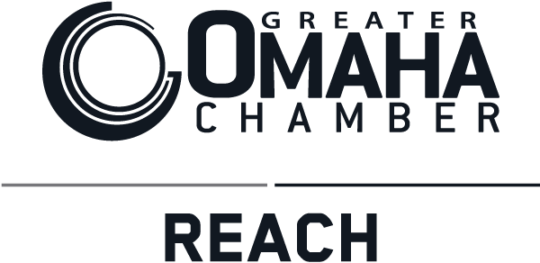
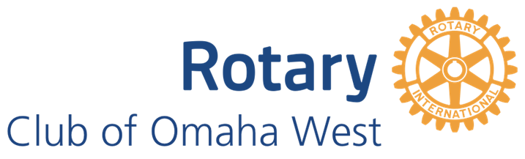
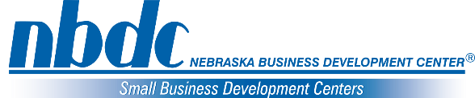
The 2022 Minority Small Business Summit Pitch Competition
Applicant (s) name (s):  Click or tap here to enter text. | Cell Phone Number:  Click or tap here to enter text. |  | Email Address:  Click or tap here to enter text. |  | Website (if applicable):  Click or tap here to enter text.
Owner’s Race:  Choose an item. |  | Hispanic/Latino:  Yes ☐ No ☐ |  | Owner’s Gender:  Choose an item.
Company Name:  Click or tap here to enter text. |  | Zip Code of Business:  Click or tap here to enter text. |  | Registered with State:  Yes ☐ No ☐
Business Legal Structure:  Choose an item. |  | Number of Employees:  Click or tap here to enter text. |  | Years in Business:  Click or tap here to enter text.
What is the story of how you started your business? (500 words or less)
Click or tap here to enter text.

What excites you about coming to work every day? (500 words or less)
Click or tap here to enter text.

What is your level-up idea? Level-up means if money were no object, what would you do to take your business to the next level (500 words or less)
Click or tap here to enter text.

How will you use the money if you win this competition? (500 words or less)
Click or tap here to enter text.

Please email all completed forms to omahawestpitchcompetition@gmail.com

May 6th, 2022 is the deadline to submit completed forms

Applicants must be available and willing to pitch their idea on June 17th, 2022 and June 23rd, 2022 at the Omaha West Rotary Meeting and also at the Minority Small Business Summit

Questions: Contact Deb Sepich at deb.sepich@doane.edu

The Minority Small Business Summit is sponsored by:

