Total Expenditures for 2017: $2,392,159,558
The U.S. Army Corps of Engineers has approximately 37,000 dedicated Civilians and Soldiers delivering engineering services to customers in more than 130 countries worldwide.
With environmental sustainability as a guiding principle, their disciplined Corps team is working diligently to strengthen our Nation’s security by building and maintaining America’s infrastructure and providing military facilities where service members train, work and live. They also research and develop technology for our war fighters while protecting America’s interests abroad by using engineering expertise to promote stability and improve quality of life.
They energize the economy by dredging America’s waterways to support the movement of critical commodities and providing recreation opportunities at our campgrounds, lakes and marinas.
And by devising hurricane and storm damage reduction infrastructure, they reduce risks from disasters.
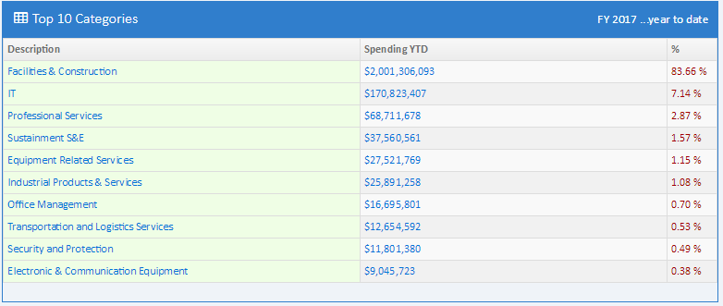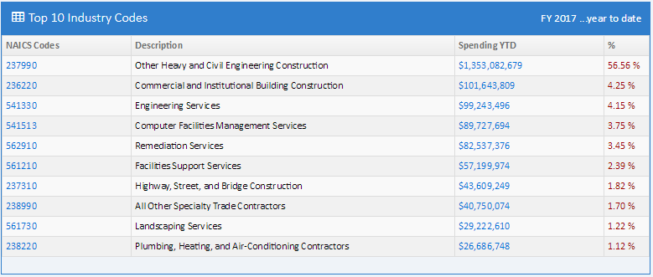
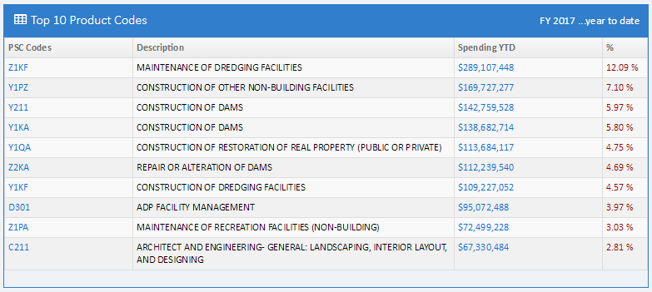
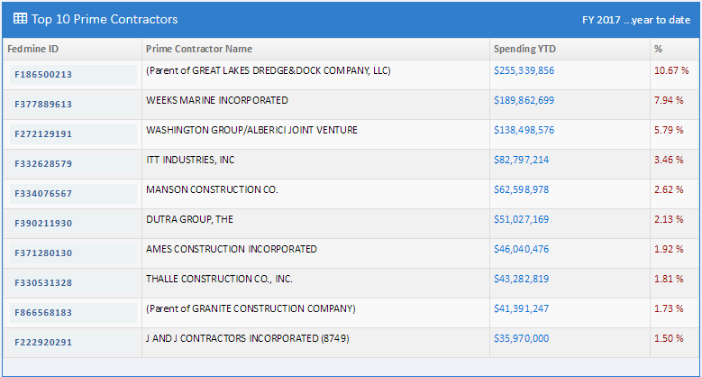
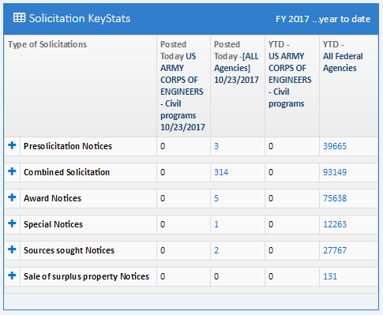
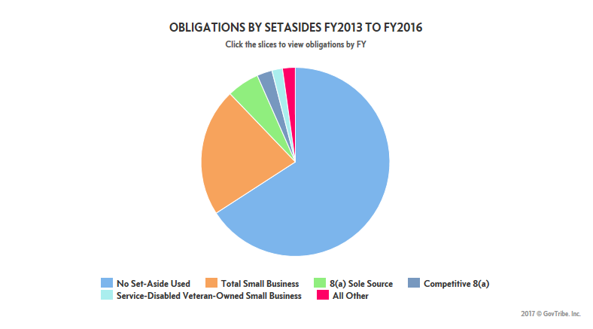
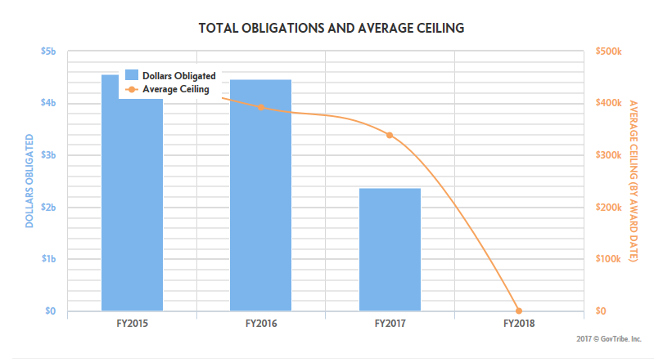

US Army Corps of Engineers – Nebraska
