Total Expenditures for 2017: $713.74 Million
The National Park Service is an agency of the United States federal government that manages all national parks, many national monuments, and other conservation and historical properties with various title designations. The NPS is charged with a dual role of preserving the ecological and historical integrity of the places entrusted to its management, while also making them available and accessible for public use and enjoyment.

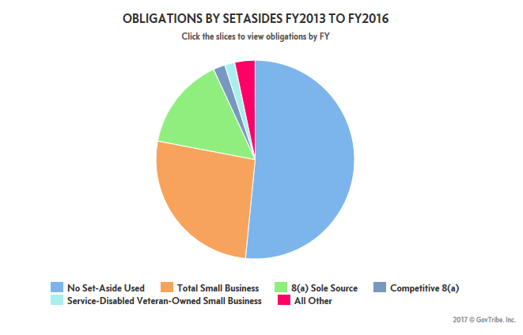
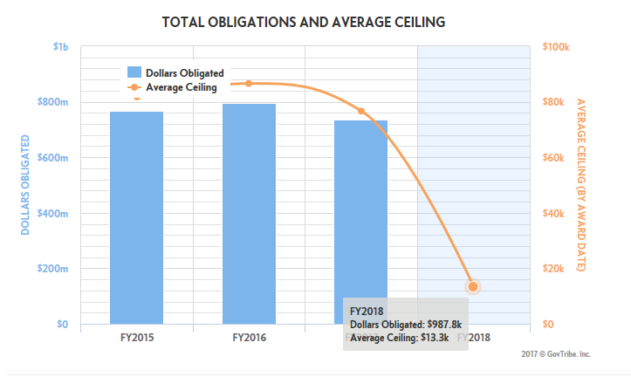

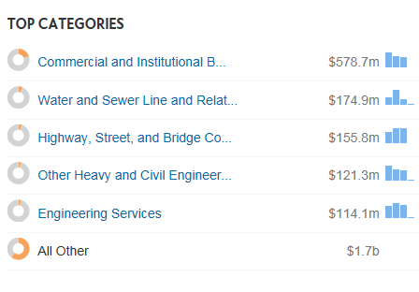

National Park Service – Nebraska
