Expenditures for 2017: $16.23 billion
Agency Profile
Name: Department of Homeland Security
Description: Formed in 2002 from the combination of 22 department agencies, the Department
of Homeland Security works to improve the security of the United States. The Department’s work includes customs, border, and immigration enforcement; emergency response to natural and manmade disasters; antiterrorism work; and cybersecurity.
Website: http://www.dhs.gov
Phone Number: 1-202-282-8000

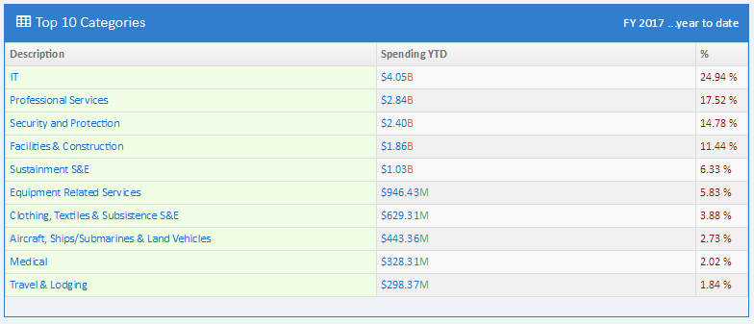
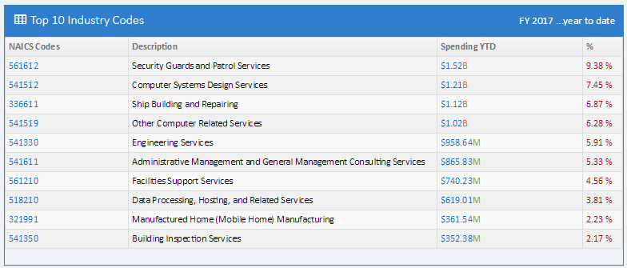
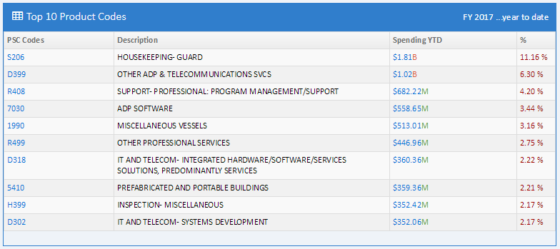
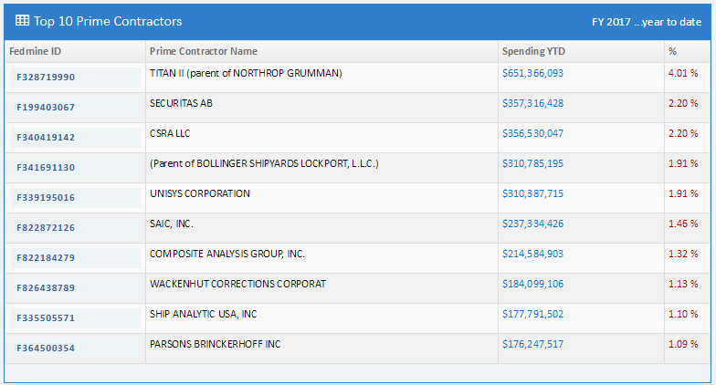
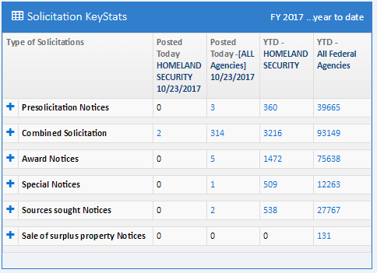
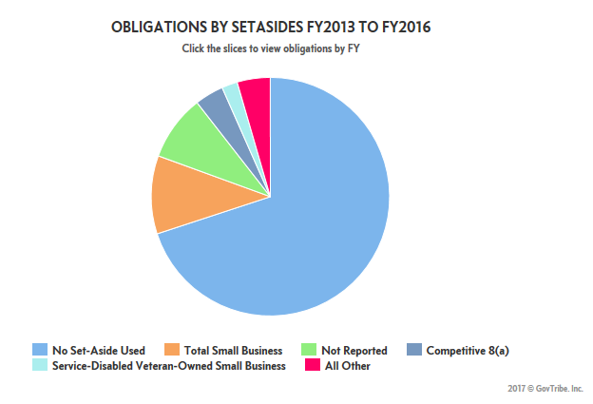
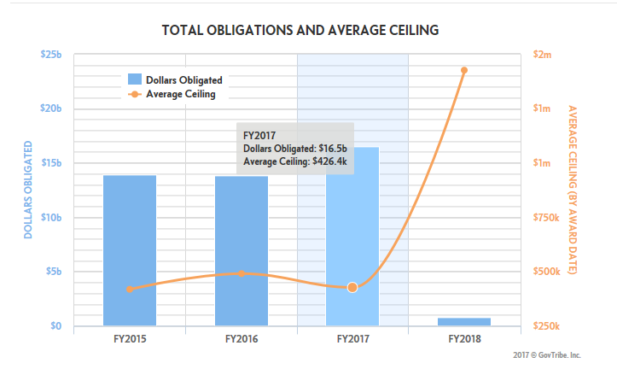

Department of Homeland Security - Nebraska
