Requesting Security Access for Electronic Time / Creating a Security Ticket

Notes:
- The employee’s PAF must be completed and they must be Active in SAP before a security ticket can be processed.
- For ESS TICKETING Only - Position numbers must be in place before you create and submit ESS Tickets for access
1). Access the Security Ticket Form by accessing Firefly
2). Click on the “SAP Security Request” Tile on your Firefly front page (near the bottom depending upon your access) under BUSINESS APPLICATIONS
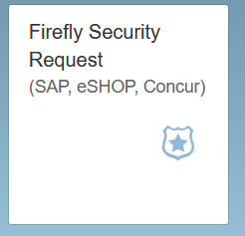
3) When you click on this, it opens up the actual Security Ticket Form. REMEMBER: (use the Employee Search button) or (manually fill in the fields) provided for the person who needs the access.
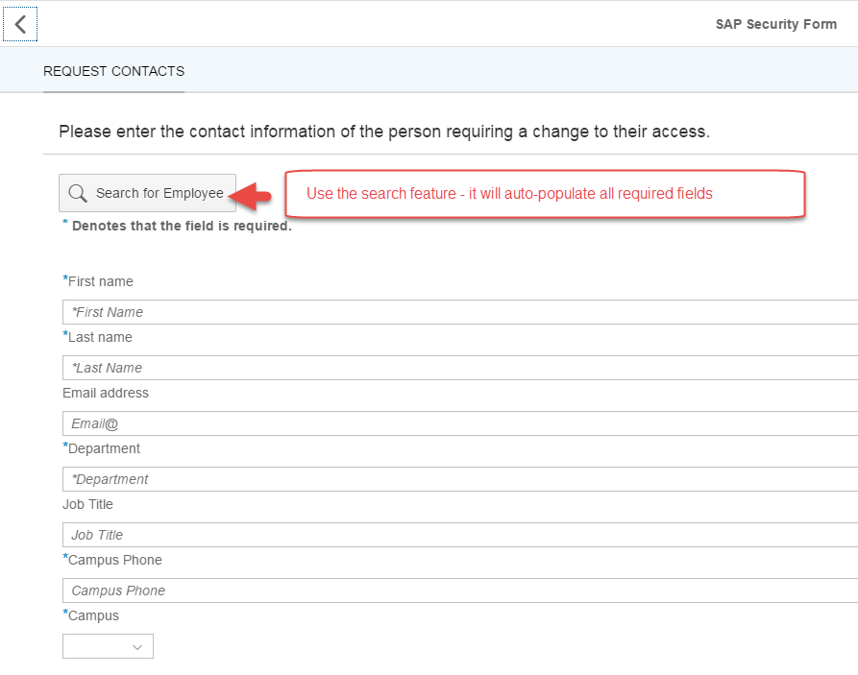
3a) Enter either the Employee Name or the Employee Personnel #
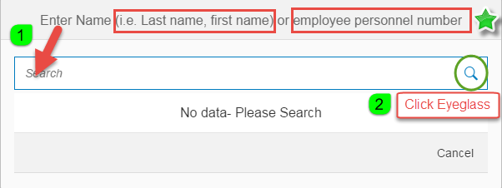

Searched-For name should appear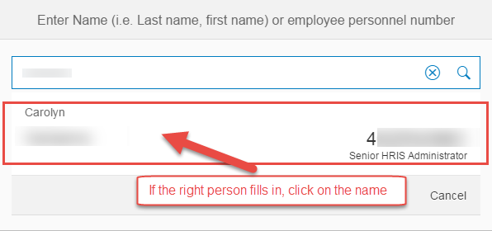
7) View of all required information auto-populated
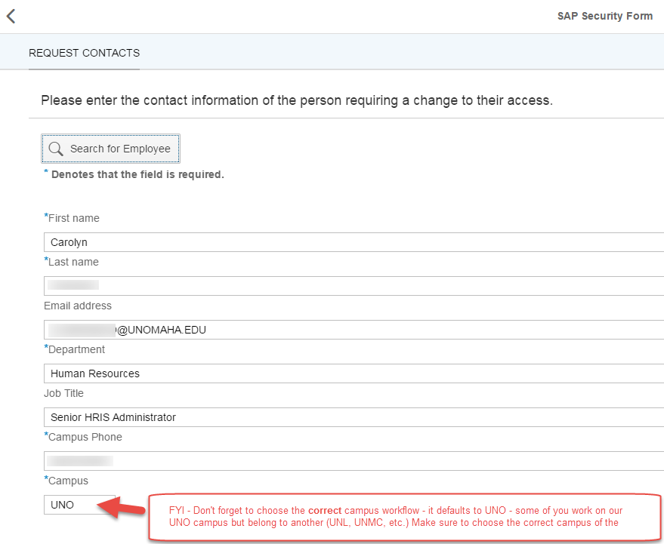
Click NEXT at the bottom RIGHT of the screen
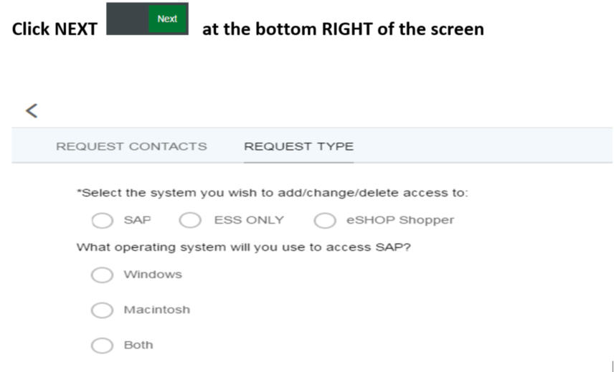
Click NEXT 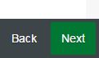 again

6) Type your request in the memo field
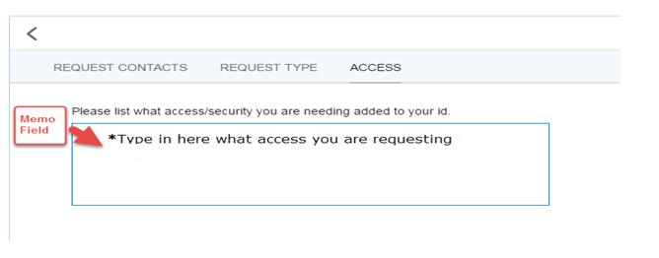

click NEXT again
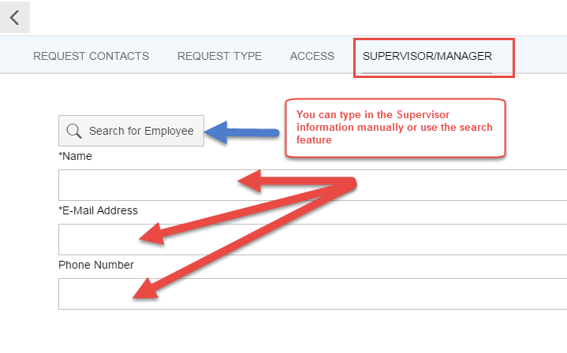
7) click SUBMIT 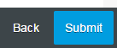

What Happens Now?
Your request is routed to UNO’s Security Coordinator who confirms the request, selects the appropriate codes, signs off on the ticket and submits it up to Central Administration for “activation”
Once Security Access has been granted, Central Administration notifies UNO’s Security Coordinator that the request has been completed.
UNO’s Security Coordinator notifies the ticket requestor that the access is now functional and ready for the individual to use.

