How to use the UNO Docusign Hiring Process for New Hires

ACCESSING YOUR HIRING POWERFORMS
HR will send you the Hiring Sheet with all Hiring Powerform Links. Save this sheet where it can be accessed whenever you need to send hiring paperwork to your new hire. These links will also be available in BOX and in SAPPHIRE
Updated Powerforms for all Hiring (Staff, Student, Hourly, Faculty, Temporary)
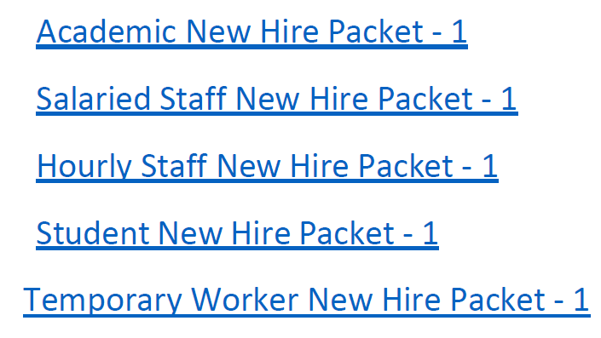
FILLING OUT AND SENDING YOUR POWERFORM TO A NEW HIRE
Choose the Powerform for the type of hire you need to send paperwork to (Academic, Salaried, Hourly or Student). Each Powerforms’ content is unique:
Academic – Welcome announcement from Academic Affairs HR Director and General Paperwork
Salaried – Welcome announcement from HR Director and General Paperwork
Hourly – Welcome Announcement from HR Director, General Paperwork and Comp Time Agreement
Student – Welcome Announcement from the Staffing Specialist in Employment, General Paperwork and Student Unemployment Letter

FYI: The General Paperwork inside of each packet includes the following:
- Welcome Announcement (including I-9 information to complete Section 1)
- PDF (Personnel Data Form)
- Direct Deposit
- Federal and State W-4
- NU Confidentiality Non-Disclosure Agreement
- Security Agreement UNO Specific
- UNO Policy Acknowledgement
- Race, Ethnicity and Gender Demographic form
- I-9 reference sheet – list of acceptable documents

Click on your chosen Powerform Link – The docusign Powerform will open. Fill it out as requested
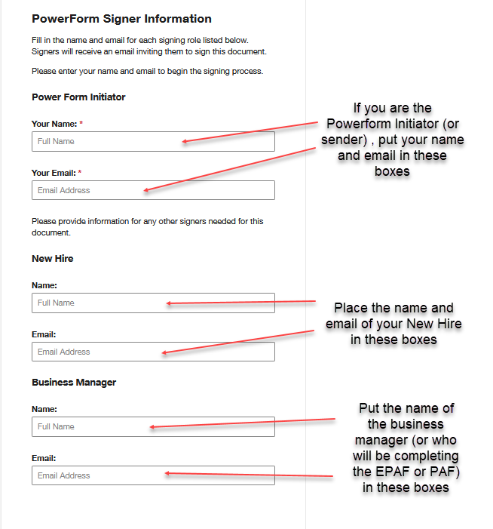

- When you have finished filling in the fields, click on .
- The Packet will open. You can scroll through it if you like just to see the content.
- You will notice that there is nothing for you to sign and the forms appear like PDF’s. That’s ok. When the new hire receives the packet, there will be fields for them to fill out.
- To send off the form, click on and then click again.
- You can now exit Docusign. The Powerform is on its’ way to the new hire.

FYI: The workflow of the powerform is below:
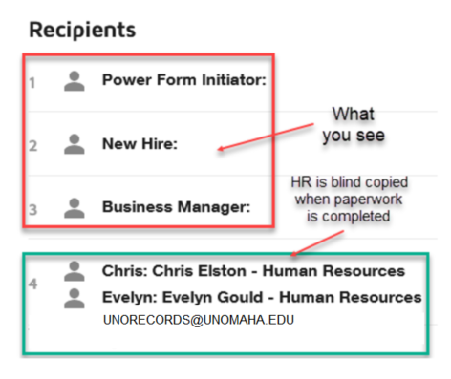
FYI: Because the Powerform is controlled by HR, you will not be able to track where the paperwork is in the workflow. If you need to check on the status of a Powerform, please contact Carolyn in HRIS to send you a screen shot of where your Powerform is in the process.
RECEIVING YOUR POWERFORM
When the new hire has completed the forms, the Business Manager (or the person you assigned as the PAF Coordinator) will receive a notice in their email to open the document
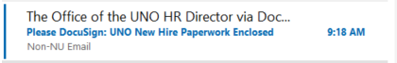
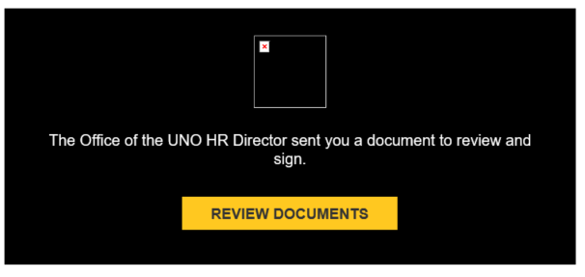
Open the Powerform
The Business Manager (or PAF Coordinator) will need to fill in a few with areas within the document.
- PDF form – fill in the Org Unit Name, Org Unit Phone, Effective Date and whether the PDF is New or an Update. Also work address information (if you have it)
- Direct Deposit form – Work address, department and work phone (if you have it)
- Information Security Agreement – requires a signature of a Supervisor (or witness)
Click . This will forward the document on to HR (it will not move on to HR unless you do this)

You now have all the information necessary to complete the EPAF or PAF. Human Resources has already receive a copy in the workflow (do not send your paper copy to HR)
FYI: You will only be entering Race, Gender and Ethnicity from the newly added Demographics form. HR Records will be entering Disability and Vets information
ROUTING THE PAF & EPAF FOR APPROVALS VIA EMAIL
At this time, please continue to route your PAF via email.
- PAF is completed and routed as an adobe PDF for approval via email
- When all approvals have been obtained, the PAF and Approvals are sent to HR (via email) for processing
- All corrections must be made at the department level before emailing to HR – HR reserves the right to send the PAF back via email for corrections

**Important note – DO NOT route any new & rehire forms with the PAF via email (Hiring forms have already been received in HR via Docusign)

