

* Dual Enrollment Growth
* In the News
* High School Course Enrollment
* College and Department Updates
* HS Teacher Checklist
* Canvas
* Mark Your Calendar
* Gen Ed Assessment
* Course Alignment

December 2017

Office of General Education and Dual Enrollment

IN THIS ISSUE

Dual Enrollment continues to grow in both size and quality and has served 37 high schools this fall alone. Student enrollment into the Dual Enrollment program has reached a record high. During the 2017 fall semester, we have enrolled 3,268 courses (see chart below) with 2,193 total distinct students. High school students are currently earning 10,838 UNO college credit hours.

“Dual Enrollment has grown 11% in student enrollment from last fall”

We look forward to visiting students at high schools this January and February to enroll them in their spring dual enrollment courses.

* [There are hidden benefits of general education](https://dailyillini.com/opinions/2017/11/11/hidden-benefits-general-education/)
* [Achieving lasting impact](https://www.insidehighered.com/views/2016/10/24/making-student-civic-engagement-truly-valuable-essay)
* [Teaching and research go hand in hand in UI Big Ideas courses](https://now.uiowa.edu/2017/11/teaching-and-research-go-hand-hand-ui-big-ideas-courses)
* [We have to rethink what “educated” means in a post-truth world](https://qz.com/1120690/we-have-to-rethink-what-educated-means-in-a-post-truth-world/)

Enrollment Keeps Growing

In the News:

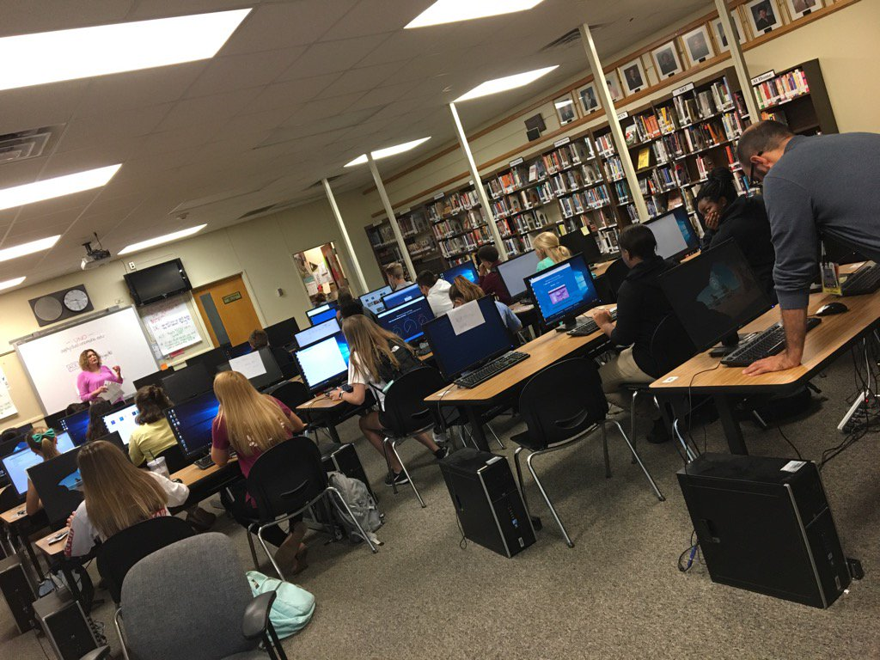

College and Department Updates

**College of Education**

NDE sponsored the 2018 Educators Rising Conference at UNO on Wednesday, November 8, 2017.  A total of 402 Nebraska high school students were in attendance who were interested in a future career in education. Along with their advisors, 306 of the 402 students came from the 12 Dual Enrollment partnership schools that offer Introduction to Teaching. Students were able to attend sessions led by master teachers in the area, UNO faculty and other organizations. Many students also took tours of the College of Education building and other campus hot spots. It was a wonderful day welcoming our DE partnerships to campus for an enriching day about careers in education.

**Foreign Languages**

On Thursday, Sept 28, 2017, 130 Omaha South Magnet High School Spanish students interested in pursuing Spanish Dual Enrollment classes arrived on campus. The Dual Enrollment Office, Undergraduate Admissions, Library Services, and the Department of Foreign Languages & Literature were all involved and worked very closely to ensure that the visit be a successful and enjoyable one. The students had the opportunity to find out about library resources and then carry out their own research, they learned about the opportunities and benefits that come with language learning, and they enjoyed a tour of our campus. All in all, due to everyone’s effort, the day was a great success, and it proved very enjoyable and extremely beneficial for the students!"

High School Course Enrollment

|  |  |
| --- | --- |
| **High School** | **Total Course Enrollment** |
| Bellevue East | 52 |
| Bellevue West | 122 |
| Bennington | 18 |
| Blair | 20 |
| Brownell-Talbot | 14 |
| Creighton Prep | 214 |
| Crete | 11 |
| DC West | 5 |
| Elkhorn | 76 |
| Elkhorn South | 20 |
| Lincoln East | 38 |
| Marian | 33 |
| McCook | 7 |
| Mercy | 39 |
| Millard Academy | 34 |
| Millard North | 23 |
| Millard South | 42 |
| Millard West | 78 |
| Mt. Michael | 12 |
| NU High School | 27 |
| Omaha Benson | 58 |
| Omaha Bryan | 126 |
| Omaha Burke | 574 |
| Omaha Central | 258 |
| Omaha North | 136 |
| Omaha Northwest | 49 |
| Omaha South | 325 |
| Papillion LaVista | 63 |
| Papillion LaVista South | 84 |
| Platteview | 34 |
| Plattsmouth | 30 |
| Ralston | 102 |
| Raymond Central | 0 |
| Roncalli | 16 |
| Skutt Catholic | 329 |
| Westside | 193 |

Canvas is a new tool created to share information more effectively. Our office has created a platform within canvas, which includes a lot of pertinent information including program resources, processes, and expectations. We are particularly excited about discussion groups that will enable you to collaborate with fellow dual enrollment instructors, share ideas with UNO coordinators, or ask questions with broader dual enrollment community.

If you have not done so already, claim your Canvas account [here](https://unomaha.instructure.com/login/canvas). Click on forgot password and set a new password. You will use your school email as your login. Once your account is set up you will be able to access Canvas here: <https://canvas.unomaha.edu>

We encourage you to provide us with feedback or simply post a comment in the “General Q&A” discussion board once you successfully login.

High School Teacher Checklist

* Confirm class rosters
* Remind students about paying their fall bill
* Log into Canvas
* Encourage students to attend Dual Enrollment events
* Input grades by Jan 12: [Instructions to post grades](https://www.unomaha.edu/dual-enrollment/_docs/posting-grades.pdf)

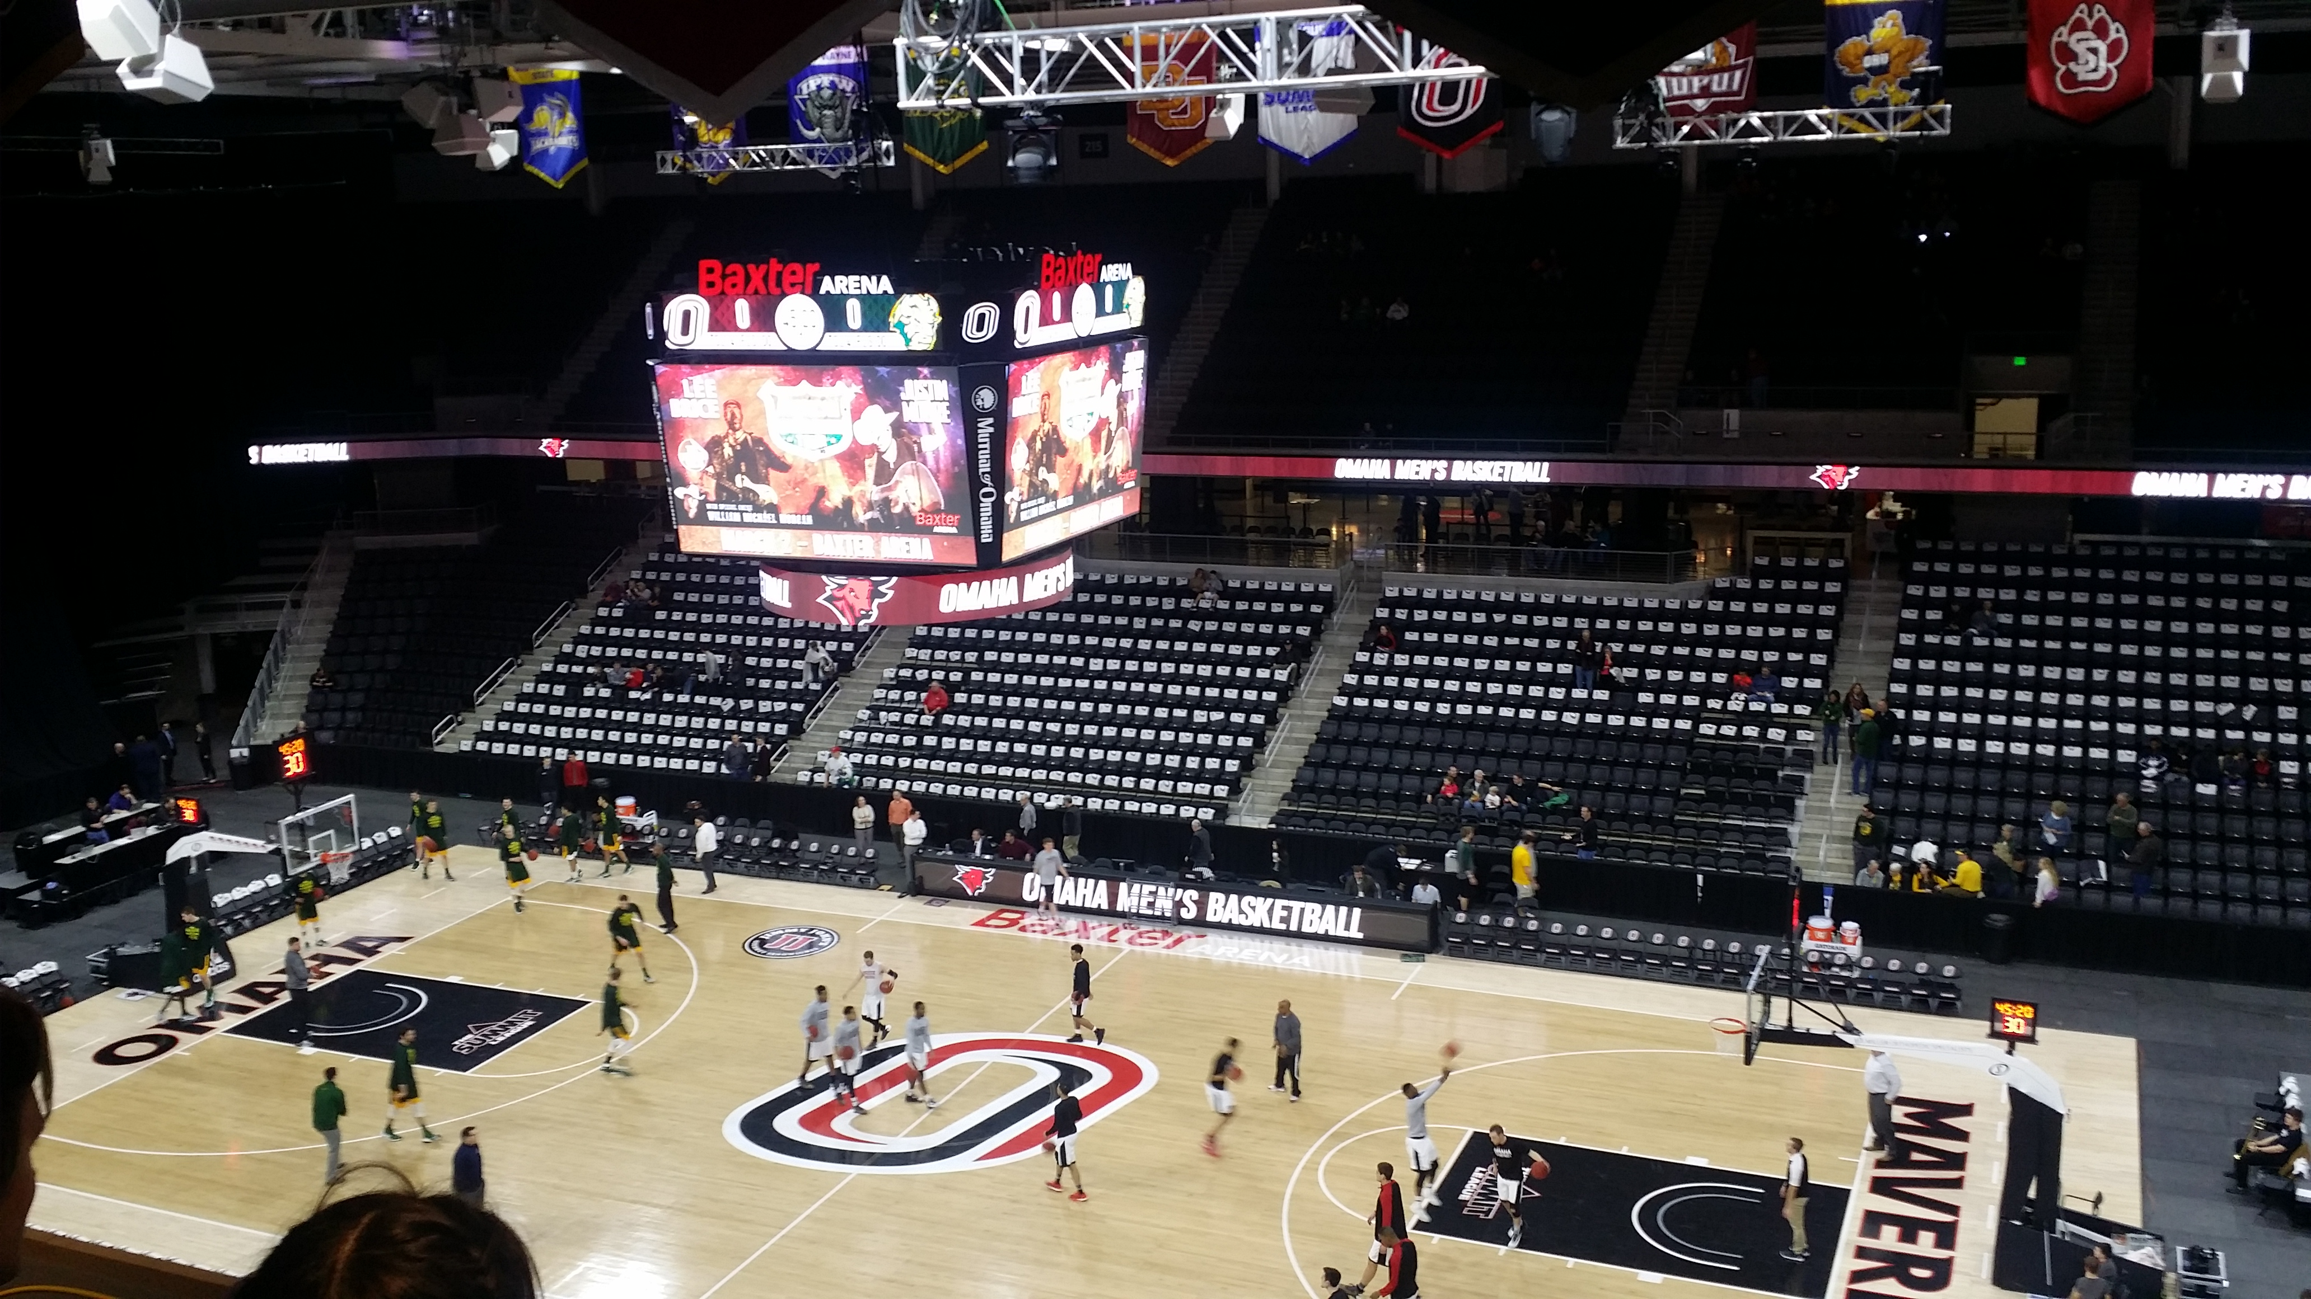

Canvas

**Basketball Blowout**

Dec 10, 2017 & Feb 24, 2018

This winter, our office will be hosting two exciting basketball tailgate events at the Baxter Arena. We encourage Dual Enrollment students and teachers to come join in the fun, which includes free basketball tickets, food and maverick gear! Students can enter to win several raffle prizes and engage with different UNO departments at our mini college fair! The tailgate parties will kick off prior to the basketball game in the scenic press box of the Baxter Arena.

**Sunday, December 10, 2017**

Tailgate Party: 11:00a.m. – 1:00 p.m.

UNO Women vs. Creighton @ 1:00p.m.

**Saturday, February 24, 2018**

Tailgate Party: 11:00a.m. – 1:00 p.m.

UNO Men vs. North Dakota State @ 1:00p.m.

To RSVP for up to (4) free tickets text “unodual” to 55678 or email us at [unodualenroll@unomaha.edu](mailto:unodualenroll@unomaha.edu)

**Other upcoming events:**

Family Information Nights: January 9 & 11, 2018

Calculus: The Musical: April 12, 2018

For more event information visit:

<https://www.unomaha.edu/dual-enrollment/events.php>

Mark Your Calendars:

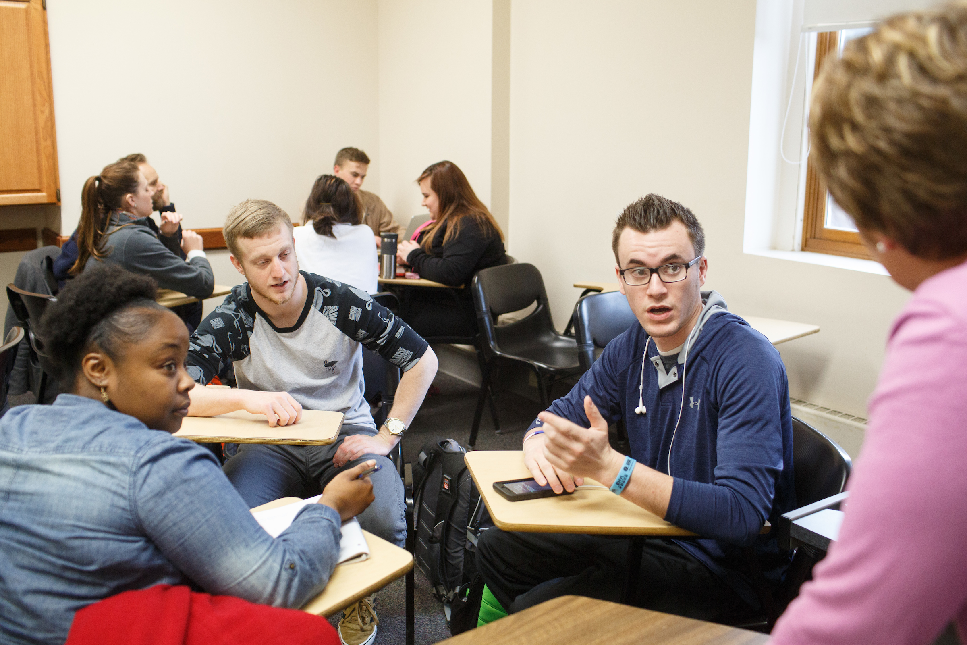

General Education Assessment

Course Alignment

The General Education curriculum provides the foundation for success in students’ academic, personal, and professional endeavors.  Assessment of the Gen Ed curriculum is important because it enables a campus wide conversation between faculty, staff, and students about the effectiveness and impact of this important component of a college degree.  It can be overwhelming to take the first step towards assessment, but it does not need to be perfect.  The most important thing is to take the first step, learn something about your courses, and make small changes to improve student learning of general education outcomes.

[The 2017-2018 General Education Assessment Guide](https://www.unomaha.edu/general-education/_docs/17-18-gened-assessment-guide-template.pdf) provides a wealth of information that can help you understand the process and requirements of assessment.  All courses that fulfill a humanities/fine arts requirement are on the Gen Ed assessment cycle this year and will need to submit an assessment report to the General Education Committee by May 11, 2018 using the appropriate [template](https://www.unomaha.edu/general-education/_docs/17-18-gened-assessment-humanities-template.docx).

It may seem obvious that the content, rigor, and expectations of dual credit courses should be aligned with the same UNO courses that are offered on campus.  However, it is sometimes unclear how to take the first steps towards increasing alignment.  Some initial actions that can be pursued by academic units include engaging in discussions with dual enrollment teachers about course outcomes, common assignments, or standardizing rubrics.  Another best practice recommended by the National Alliance of Concurrent Enrollment Partnerships (NACEP) is a discipline specific orientation for all new dual enrollment teachers.  There is no single way to ensure consistent alignment of dual credit courses; however, the journey begins with a single step.

OFFICE OF GENERAL EDUCATION AND DUAL ENROLLMENT

Eppley Administration Building | 6001 Dodge Street | Omaha, NE 68182

402.554.3810 | dualenroll.unomaha.edu