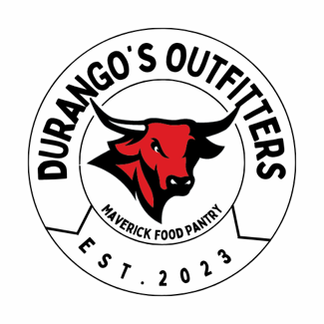

Durango’s Outfitters Donation Acceptation Process

When we are open to donations, items can be dropped off at the Maverick Food Pantry or the DASH office. We ask donors to bring clean, gently used items in a clean bin, paper bags, reusable bag, or folded nicely in a garbage sack. We also ask donors to label the donated bin with their name and email address. Our standards and process are below.

## What we accept

Durango’s Outfitters accepts donations on a “needs basis,” meaning that we reserve the right to open and close our donation acceptance when our inventory has reached capacity.

We also reserve the right to refuse donations if they do not meet our following standards:

* No stains
* No tears/rips
* No visibly worn items (pilling, stretched out, etc.)
* Non-laundered items
* If any bugs or bug remnants are found in the donation bin/bag
* The clothing has any obvious smells (not clean, cigarette smoke, etc.)

A Durango’s Outfitters representative will check through the items to ensure they meet our standards (specific instructions below). If not, the items may be returned to the donor, passed on to community organizations who can use them, or recycled through [Trashie](https://www.trashie.io/how-we-recycle).

## Checking the items

After a donation has been accepted a Durango’s Outfitters representative will go through the following process to ensure it meets our standards.

1. Check for any of the above signs of obvious wear and tear
2. If an item has small areas that could be patched or upcycled; place it in the upcycle bin for future “up-cycling” events
3. If an item does not meet your standards or you feel as though it wouldn’t serve our student base, place it into one of the following bins:
   1. Donations: these items could still be worn by the greater Omaha community
   2. Trashie: any items beyond repair or not of good enough quality to pass on should be recycled in one of the trashie bags. DO NOT SEAL THIS BAG!! Only the President or Vice President can seal and ship these bags, so please let them know post-sorting if the bag is full.
4. After the items have been checked and sorted, they can be put on hangers. Any kind of shirts, blouses, sweaters, jackets, and dresses can be placed on regular hangers. Please hang pants and skirts on designated “pant hangers.”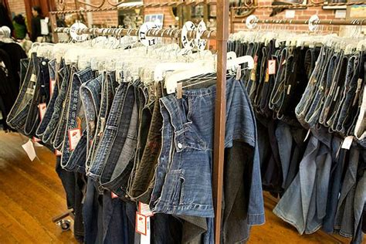
5. Items are then sprayed down with our anti-bacterial spray or laundered through H&K.

All items in the closet are checked every two weeks for quality, as well as thoroughly inspected during and after monthly pop-up events.

## Leftovers & Sustainability

Our inventory is constantly changing. This ensures that students will always find something new at each pop-up. If items of clothing have been at pop-up events for more than a semester, they will be passed on to a community partner.

One of our missions at Durango’s Outfitters is to show our campus that sustainability initiatives do not need to be costly. By accepting donations from our community, we can create a more circular clothing economy and work to avoid fast fashion.

**Our donation process ensures the quality and cleanliness of our closet and items going out into our community – it is something that we are proud of and stand behind. If any problems with this process occur, please email us at** [**durangosoutfitters@unomaha.edu**](mailto:durango’soutfitters@unomaha.edu)**. We want to provide our guests with a pleasant experience and hope they will come back to visit in the future!**