SOCIAL WORK ONLINE LEARNING 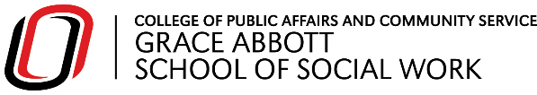

Is online learning right for me? |  |  |  |  | Free UNO Services to Help
Do you have reliable internet access and a quiet place to study? |   NO | Consider whether you can improve your setup before enrolling. |  |  | - UNO Equipment Checkout for Laptops and WiFi Hotspots  - UNO ITS Help Centers  - Microsoft 365 Suite for UNO Students
YES

Do you prefer a flexible schedule where you can learn at your own pace? | NO | You might prefer an in-person program or use services to help you stay on top of your schedule. |  |  | - On-Campus Support Groups  - Counseling and Psychological Services (CAPS)  - Durango’s Advancement and Support Hub (DASH)  - Wellness Coaching
YES

Do you feel comfortable expressing your thoughts in writing (e.g., discussion boards, email)? | NO | Look for programs with set class-times and utilize writing services. |  |  | - UNO Writing Center  - UNO Speech Center  - TRIO Project Achieve  - Language Lab for English Learners  - Read&Write
YES

Is staying in your community or avoiding relocation a priority? | NO | You might enjoy the on-campus experience in Omaha! |  |  | - UNO Events Calendar  - Housing and Residential Life  - Student Health Center  - Maverick Food Pantry and Diaper Bank
YES

Consider online learning! |  | View our in-person program options!

