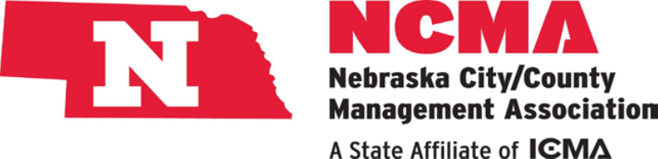
Sponsorship Opportunities

Level #1 – $250
- Name & Logo - in packet
- Logo Presence – breakouts
- Meal Registration
Thursday lunch

Level #2 – $500
- Name & Logo - in packet
- Logo Presence – breakouts
- Booth space
- Meal Registration
Thursday – lunch & dinner

Level #3 – $1,000
- Name & Logo - in packet
- Logo Presence – breakouts
- Booth space
- Meal Registration
Wednesday & Thursday
- Wednesday Evening Event
- Recognition & ability to address membership prior to a conference break
- Registration for one extra business rep

Level #4 –$2,000 – Keynote
- Name & Logo - in packet
- Logo Presence – breakouts
- Booth space
- Meal Registration
Wednesday & Thursday
- Wednesday Event Pass
- Recognition & ability to address membership prior to a conference break
- Registration for two extra business representatives
- Special Recognition throughout conference
- Welcome Address with NCMA President for Keynote Speaker
- Acknowledgement with Speaker
- Reserved Seating with Speaker at Thursday lunch

2023 NCMA Annual Summer Conference
Papillion Landing – Papillion Nebraska
June 28 – 30, 2023

Sponsorship Registration

Sponsor Business: ______________________________
Address: _____________________________________
City: ___________________ State: _____ Zip: ______
Contact Person: _______________________________
Cell Phone # ___________________________________
E-mail: _______________________________________
Booth Space Requested: (circle) Yes / No
Additional Business Reps (if applicable- Level #3 or #4)
Name(s) _________________ ___________________
Level of Sponsorship: (check level of sponsorship)
- Level #1
- Level #2
- Level #3
- Level #4 – Keynote Speaker

Please make Checks payable to NCMA. Send to
registration form and check to the attention of:

NCMA
1335 L. Street
Lincoln, NE 68508

For more information, please contact:
Amber Powers, NCMA President-Elect, City Administrator
City of Papillion; apowers@papillion.org or 402-597-2032 (office).

