CEHHS
Counseling Department
Annual Program Report 2021
Clinical Mental Health, School Counseling, Student Affairs in Higher Education
Report 2021
Dr. Chasek, Department Chair
March 2022

Counseling Department

Mission Statement: We Train Colleagues!

The mission of the UNO Counseling Department is to provide high quality academic and clinical preparation leading to eligibility for licensure and certification as professional counselors. Through a rigorous, evidence-based curriculum designed to train critical thinkers and reflective practitioners, candidates are prepared to work with diverse clients across multiple professional settings and engage and remain active as advocates and future leaders within and for the counseling profession and those we serve. As dedicated practitioners, reflective scholars, and responsible citizens, our graduates are prepared to fill the need for licensed/certified clinical mental health counselors, school counselors, and student affairs professionals across the Omaha metropolitan region, Nebraska, and the nation.

Counseling
The 60 credit M.S. degree with a concentration in CMHC includes the coursework and field experiences (practicum/internships) required for licensure as a mental health professional in Nebraska. Students who complete two additional elective courses (COUN 8686 & COUN 8696) will also have completed the academic requirements for provisional licensure in the area of Alcohol and Drug Counseling (LADC) in Nebraska.
Clinic
Our clinic, in existence since 1977, is staffed by advanced students in the UNO Graduate Department of Counseling and supervised by licensed department faculty. Our Community Clinic offers individual and group counseling for children, adolescents, adults, couples, and families.

School Counseling
The 48 credit M.S. degree with a concentration in School Counseling includes the coursework and field experiences (practicum/internships) required for certification as a School Counselor in Nebraska.

Student Affairs Higher Education
The 39 credit M.S. with a concentration in SAHE includes coursework and field experiences for individuals interested in careers in higher education. This program offers a Master of Science degree with a thesis option for individuals interested in a career in Student Affairs in Higher Education.

Faculty and Staff
Dr. Tina Chasek, Chair
Dr. Ashley Blount, SAHE Coordinator
Dr. Charmayne Adams, CMHC Coordinator
Dr. Abby Bjornsen-Ramig, Clinical Training Director
Dr. Elizabeth Tolliver, SC Coordinator
Dr. Isak Kim
Mr. Thang Tran
Barb Newell, Administrative Assistant
Kara Schneider, Graduate Assistant
Jacob Ignagni, Graduate Assistant

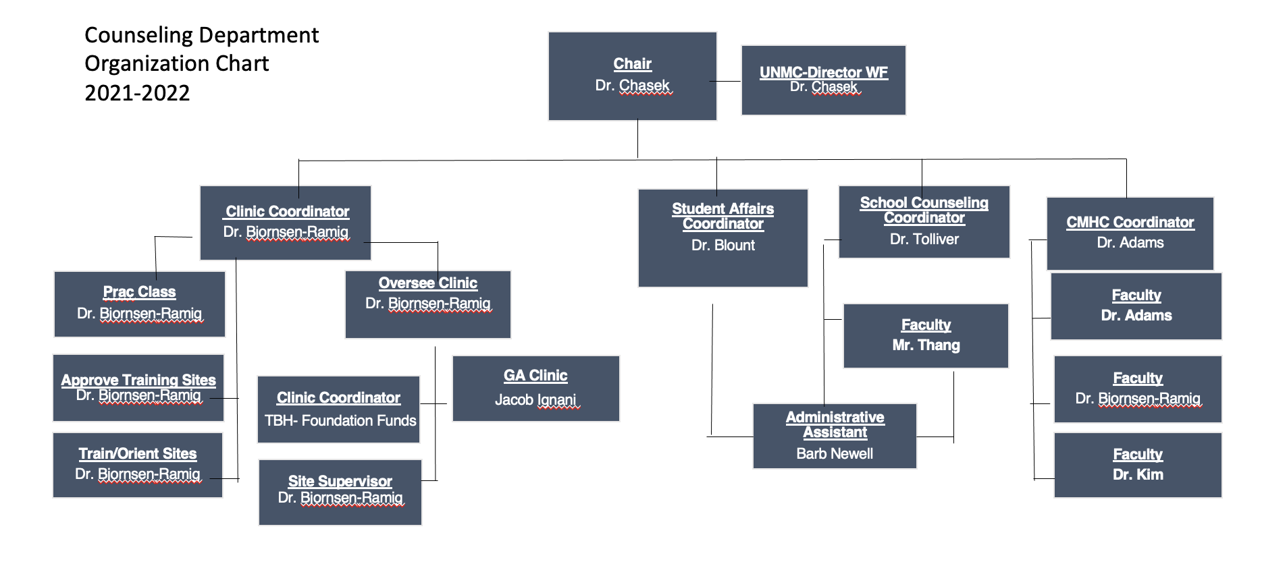

Part 1

2021 Counseling Department Accomplishments

Teaching, Research, and Service

The Counseling Department is committed to excellence in training colleagues as demonstrated in the areas of teaching, service, and research in counselor education. The following are the accomplishments for the 2021 year in each area.

Teaching
- Excellence in teaching is evident in the Student Evaluation scores across the courses in Counseling. For the period of Fall 2020 to Fall 2021. On the 5.0 scale, the core faculty evaluation scores averaged 4.48 and with adjuncts included a 4.43 across all courses. This indicates students are experiencing an engaging and relevant learning experience in the classroom and clinical experience.

- Dr. Abby Bjornsen-Ramig was awarded the 2021 Alumni Outstanding Teaching Award for her teaching and commitment to student success.

- Further evidence in teaching excellence, is the school counseling’s partnership with UNO’s Service Learning Academy in providing group counseling services in the area schools.

Clinical Services – Service Learning
Community Clinic
- The UNO Counseling Department’s Community Clinic is a teaching clinic that continues to provide counseling services to the Omaha community. Students in the COUN 8220 Counseling Practicum course provide clinical services for clients at a low cost. The students are supervised by licensed clinical faculty who also provide instruction in evidence-based techniques and best practices. Over the course of the 2020-2021 year, the clinic transitioned into providing telehealth counseling sessions and then returned to a hybrid model of in person and telehealth visits in 2021. Six practicum students are placed in the clinic each semester, with the hope of adding another section of practicum to increase access to services. This past year, 24 counseling students provided clinical services for a total of 1,140 clinical hours (Fall 2020 and Fall 2021).

Goodrich Groups- Clinical Curriculum Development Phase
In the Fall of 2021, Dr. Abby Bjornsen-Ramig, UNO Counseling Clinical Training Director, and Kennan Krick, Goodrich Student Services Specialist, licensed counselor, and UNO Counseling Alum, developed a pilot project to provide group counseling services to Goodrich Students beginning in the Spring 2022 semester. The groups are designed to provide needed mental resources and supports to Goodrich students and provide an opportunity for experiential learning in clinical group practice for the counseling students. The group experience is based on the 8 dimensions of wellness at UNO and serves as a recruitment tool to draw historically underrepresented students to the graduate counseling program at UNO.
Internships
- The CMCH program works with many community partners to provide critical mental health services to the metro area in the form of internships. One newer partnership highlighted this year is UNMC Behavioral Health Education Center and the Nebraska Department of Correctional Services. This partnership provides clinical internship experiences for graduate level trainees in counseling. With clinical supervision, trainees provide direct care to inmates and individuals needing mental health care. Financial support is provided for the full term of the required internship. This past year 3 students took advantage of this opportunity and provided 600 hours of clinical services to this underserved population. Furthermore, the counseling department provided students with internships experiences in the community. A total of 189 clinical placements were made with a total of 38,340 clinical hours provided in the community.

Research
- In the area of research, core faculty in the counseling department have been active in pursuing research excellence and external grant funding. Funded research project for 2021 totaled $138,989, with projects submitted for grant funding totaling $707,740. Decisions are pending on these funds, but they range from local projects with UNMC and the State of Nebraska to NIH funded projects.

- In 2021, the 6-core faculty had the following production in the area of research:
  - 20 publications; includes 4 book chapters and 16 peer reviewed manuscripts
  - 52 National and State peer reviewed presentations on mental health related topics

- In recognition of her early and on-going engagement in scholarly activity, Dr. Ashley Blount was awarded the 2021 American Counseling Association Garry R. Waltz Trailblazer Award, a very prestigious national award.

Service
- In the area of service, the 6-core faculty contribute many hours to the Profession and the University through service in
  - 45 Department, College, and University committees,
  - 18 State committees,
  - 24 National committees.

- Dr. Chasek was awarded the 2021 Distinguished Partner Award through the Nebraska Department of Education, Nebraska Career and Technical Education for her working in developing opportunities for students in the area of behavioral health careers.

It has been a highly productive year for the Counseling Department despite numerous changes including a new chair, retirement of a core faculty, realignment of duties within the department and supporting a remote full time faculty member. A new School Counseling to Mental Health Counseling certificate was implemented with 21 students taking courses to finish the courses necessary for a license to practice mental health counseling. But perhaps the most important metric to measure the mission of the department in our efforts to train colleagues is the number of students who graduated. In 2021, we graduated 50 students who became our colleagues!

Part 2

CMHC Program Evaluation

The Clinical Mental Health Program has been in transition from the CACREP 2009 standards to 2016 standards. The process has been very helpful in gathering data to analyze the strengths and areas of improvement for the CMHC program and the department over the past year. Faculty have been engaged in a process of evaluating student learning outcomes, program performance, data collected, program plans, and the curriculum to move toward enhancing the program as we come out of the changes caused by the pandemic. The following areas of evaluation speak to the changes and transitions to make the program the strongest it has ever been. Data will begin to be collected over the 2022 Spring, Summer, and Fall Semesters.

2021 CMHC Student Learning Outcomes

Student Learning Outcomes (CACREP 4.A, F, G)
Students’ learning and progress throughout the program is evaluated in the areas of knowledge, skills, and professional dispositions. Student learning outcomes include:
- Key Performance Indicators (KPIs) across the curriculum in knowledge, skills, and dispositions. KPIs assess student learning in CACREP’s eight core areas of Professional Counseling Identity and the CMHC Specialty Area.
- Mastery of curriculum content as evidenced by scores on the comprehensive exams
- Mastery of clinical skills as evaluated by faculty and site supervisors on the formative evaluation in the advanced internship course.

2021 Program Performance Measures

The transition from the CACREP 2009 standards to 2016 Standards has included identifying ways to not only measure individual student performance but to also measure the program’s performance as a whole. Faculty have determined that the following measures are critical to ensure that the program is operating in a way that supported student’s learning and the community needs, in addition to supporting faculty performance. Below the performance measures selected to do that and the data from the Spring 2022-Fall 2022 semesters. Each area will include data and discussion points as highlighted by faculty decisions.

Program Performance Measures (CACREP 4.A, B)
The program performance measures are evaluated throughout the program and are used to assess the programs’ goals and objectives. These measures include:
- Admission data
- Student demographic information
- Aggregate Key Performance Indicators for students
- Pass Rates on Comprehensive Exam
- Site Evaluations completed by students in Practicum and Internship courses
- Student Course Evaluations of all faculty (Core and Non-Core)
- Graduate Surveys
- Graduation rates
- Licensing rates
- Employer Surveys

