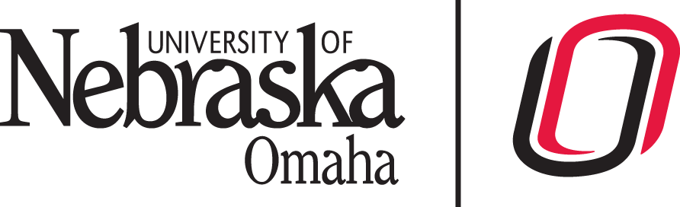
UNIVERSITY OF NEBRASKA AT OMAHA
COLLEGE OF BUSINESS ADMINISTRATION
INTERNSHIP LEARNING AGREEMENT

To be completed by: Company Internship Supervisor

Student Intern Information
Intern Name | Concentration (Major)
Email Address | Phone

Internship Supervisor: I have discussed this internship with the intern and we have agreed upon the assigned work components delineated in the Learning Objectives. I agree to meet with the intern regularly to provide assistance, training, and feedback in order to progress towards the learning objectives.

I agree to provide meaningful and interesting work of educational value for the intern (less than 25% clerical duties). Work assigned will be consistent with the agreed-upon Learning Objectives.
I also understand that an evaluation of the student will be emailed to me at the end of the semester. I will complete the evaluation form, meet with the intern to discuss the evaluation and return the complete form to the Internship Coordinator by the requested date.

My signature below verifies that this intern will receive at least minimum wage for this internship.

Internship Supervisor Signature | Date

Please return completed form to:
Dr. John Erickson (johnerickson@unomaha.edu) Human Resource Management
or
Dr. Erin Pleggenkuhle-Miles (erinpmiles@unomaha.edu) Management and Leadership
or
Dr. Steve Schulz (sschulz@unomaha.edu) Logistics and Supply Chain Management

