You may be in a discipline or department where faculty regularly read and give helpful comments on your written work. You might be in a discipline or department where this is a much rarer occurrence, or where faculty are not good at giving feedback. Whatever the case, you need to see faculty feedback as part of your writing process.
Remember:
- Not all faculty are trained in giving feedback
- Giving feedback takes time; revising will too
- This is your project; take ownership
- Do not limit yourself to feedback from faculty

Road Map Documents
Before starting a thesis or dissertation, you should have:
- A formal proposal/prospectus
- Outline (sometimes included in prospectus)
- Timeline
  - Include dates for each major section/chapter
  - Include when faculty will return feedback on each section/chapter
- Samples of theses/dissertations approved in your department
  - No more than three years old
  - Preferably approved by one or more members of your committee
These documents guide your writing process and the feedback you get from faculty. Providing a clear sense of the timeline and project scope should keep faculty feedback focused; it can, for example, eliminate suggestions of additional sections or chapters weeks or days before deadline.
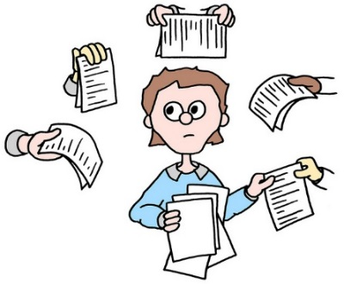
Soliciting Faculty Feedback
Every time you send writing to faculty, include a brief note that guides the response you want. Not including such a note, gives faculty complete control. Without guidance faculty can get frustrated, they can focus on issues/details that you are not concerned about at this stage, they can overwhelm or underwhelm you with comments/suggestions/editing marks.

Often called Author’s Notes, the note should:
- Identify where you are in the writing process with this text. Early draft of finished copy?
- Make clear what, if any, changes you have made since the last time your reader has seen this project
- Point out the strengths/weaknesses of this draft
- Tell your reader what kind of feedback you want. Identify specific issues, sections, questions, etc. that you want them to focus on when responding
- Avoid prompts like “just point out what you see” or “let me know what you think”—these can frustrate readers and lead to scattered feedback
- Suggest a timeline for the faculty member’s response
Writing from Faculty Feedback
Once you get feedback on your writing, take some time to read that feedback. Read feedback more than once, as you are likely to see any feedback as negative on your first read. Then, do the following:
- Make a list of comments/suggestions that apply beyond this draft; keep this list close whenever you write so you can avoid those errors/issues
- Categorize the feedback you get (grammatical, citation, organization, content, etc.)
- Focus first on addressing questions or suggestions that are substantive; it makes little sense fixing typos, grammar, or punctuation issues if you are going to re-write or reorganize
- Pick your battles—if the suggestion is annoying but minor, it may make life easier to do as suggested
- Choose which comments/suggestions to follow. Ignore others. This is your project. Faculty want you to own the project, not to simply do everything they suggest
- If you have feedback from multiple faculty members and some of that feedback seems contradictory, prioritize feedback from your advisor/chair
- When you have questions about feedback or about how to follow through on that feedback, ASK.

Responding to Faculty Feedback
Faculty are busy and probably think their feedback was crystal clear when they wrote it. So, when you have questions make sure you seek clarification as clearly and quickly as possible.
- Phrase questions by offering your understanding
  - “When you write “X” I understand that as you asking me to “Y.” Is my reading of your comment correct?
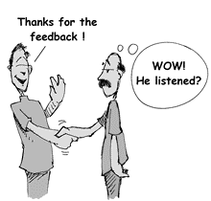
- Ask for revision options when you are stuck
  - “I understand your comment that I need to “X,” but I am not sure how to do it. Can you help me think of options for doing “X” or is there an example in a published article you can point me toward?
- Offer your rationale for any comments or suggestions that run counter to your vision
- Request a meeting to discuss the faculty member’s feedback and your revision plan. Often, faculty are much clearer (and more positive) when talking through feedback
- Thank faculty when they provide helpful feedback; the more specific you are in thanking them, the more helpful they will be to you and others in the future

Writing Center as Medium
Consultants in the UNO Writing Center can help you craft author’s notes, interpret comments, work from, and respond to faculty feedback. Schedule an appointment and bring both a clean copy of your draft and a copy with the faculty member’s comments.

