University of Nebraska at Omaha
Philosophy Colloquia Series
presents
Songs, Solos, and Standards:
The Role of Shared Intentions in Collective Music-Making
Friday, November 15, 3pm, 216 Arts and Sciences Hall
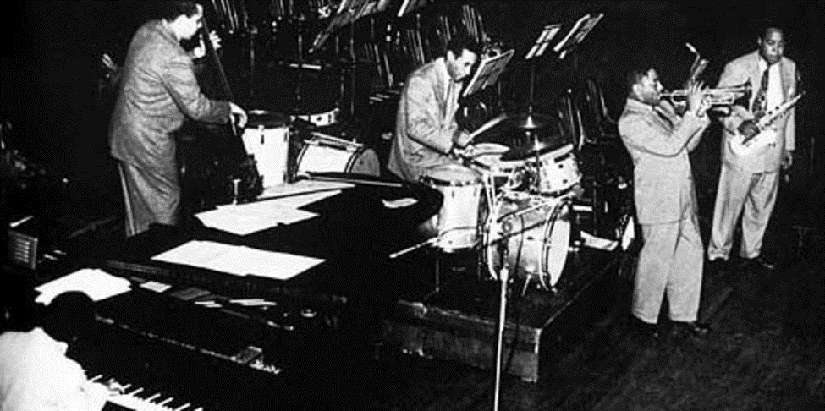

Kevin J. Ryan Jr.
University of Nebraska at Omaha
Regardless of genre, almost all songs are ultimately the result of a collaborative process. Even the greatest solo performers work with writers, producers, and audio engineers, after all.
While the fact of the matter may be that music-making is collaborative, it’s not clear how such collective processes are realized in practice. In order to address this issue, my presentation will focus on musical collaborations during open jams. Particular consideration will be placed on jazz performance, but we shall consider other genres as well. In doing so, I suggest that we will find the intentions at play in these cases cannot be explained by looking at the isolated intentions of each performer. Instead, shared intentions are an integral part of our explanatory story for everything from how a group can perform without rehearsing together beforehand through how your favorite song was made in the first place.

