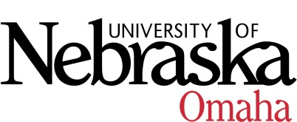

UNIVERSITY OF NEBRASKA AT OMAHA

EDUCATIONAL POLICY ADVISORY COMMITTEE
SUMMARY
Friday, April 14, 2017
8:00 AM
202 Eppley Administration Building
Members present: Gwyneth Cliver, Patricia Meglich, Ann Luther, Kerry Ward, Katie Bishop, Ann Coyne, and Associate VC Deborah Smith-Howell presided

- Announcements/Discussion
  - Course Form update
  - Committee agreed to meet at 9:00 AM for 2017-18 academic year.
- Approved summary from 3-10-17
- The following curriculum items were report items only:
  - Non-Profit Management Graduate Certificate
  - BA in Sociology-Alternative Delivery
  - BS in Criminology and Criminal Justice-Alternative Delivery
- Course Syllabi
The following new course(s) were approved:
- SOWK 8626 Trauma and Resilience, 3 hrs.
- ART 3910 Intermediate Printmaking, 3 hrs.
- AVN 1500 Introduction to Unmanned Aircraft Systems, 3 hrs.

The following revised course(s) was approved:
- ART 1210 Foundation 2-D Design and Visual Literacy, 3 hrs. (name change and parameters of course)

Next meeting Friday, May 12th at 8:00-9:30, Eppley Administration Building 202:

