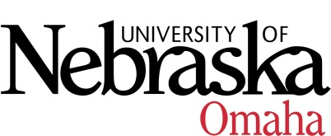

UNIVERSITY OF NEBRASKA AT OMAHA
EDUCATIONAL POLICY ADVISORY COMMITTEE
SUMMARY

Friday, November 11, 2016
8:00 AM

Meeting was cancelled. Committee reviewed the two courses and required additional edits to be made.

- Approved summary 10-14-16

- Course Syllabi

New Courses
- SOWK 4050 Ethnic Diversity and Social Work Practice, 3 hrs.

Revised Courses
- MUS 3640 Music Education Internships, 3 hrs.

