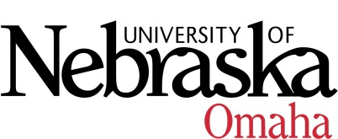

UNIVERSITY OF NEBRASKA AT OMAHA

EDUCATIONAL POLICY ADVISORY COMMITTEE
SUMMARY

Friday, January 16, 2015
9:30 AM
202 Eppley Administration Building

Members present: Gwyneth Cliver, John Erickson, Richard Stacy, Marshall Prisbell, Dhundy Bastola, Nora Hillyer and Associate VC Smith-Howell facilitating.

- Discussion
  - Reporting Student Sexual Harassment, Sexual Violence, or Sexual Assault
Confirmed recommendation for reporting student sexual harassment, sexual violence or sexual assault: Statement be posted on all students’ Blackboard site rather than incorporated into master syllabi or course outlines. This allows for widespread distribution; ensures consistent information; and maintains the syllabus for academic content. Statement should be clear and brief with a link to a site with complete and detailed information. In all information (Blackboard statement and detailed website) it needs to be clear who (individual/groups) are required to do mandatory reporting.

  - Articulation Process
Review and discussion of Articulation Agreement Subgroup. Agreed that all articulation agreements (university-wide and program specific) should be routed through EPAC as a report item. Committee members will review, and when appropriate, provide feedback.

- Course Syllabi Description/Prerequisites:

The following new courses were approved:
- WGST 4070 Gender and Leadership: Community Action Project, 3 hrs.
- NEUR 4900 Special Topics in Neuroscience, 1-3 hrs.
- BSAD 2600 Ethics in Organizations, 3 hrs.
- MGMT 4540 Supply Chain Management Internship, 1-3 hrs.

The following new course(s) was approved pending minor edits:
- IASC 2980 Special Topics in Information Assurance, 1-3 hrs.

