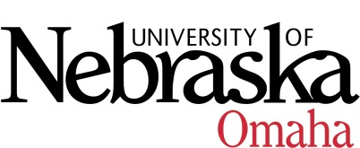

UNIVERSITY OF NEBRASKA AT OMAHA

EDUCATIONAL POLICY ADVISORY COMMITTEE
SUMMARY
Friday, November 9, 2018
9:00 AM
202 Eppley Administration Building

Members present: Darren Pettit, Christina Dando, Patricia Meglich, and Associate Vice Chancellor Smith-Howell presided.

- Curriculum
  - Approved - UNO STEM Trial Center (action item)
  - Approved - BA/BS in Medical Humanities (action item)

- Course Syllabi
Approved the following new course(s):
- MATH 8626 Iterated Function Systems and Fractals, 3 hrs.
- MUS 1430 Commercial Music Theory I, 3 hrs.
- US 2800 Career Competencies for Professional Success, 3 hrs.

Approved the following revised course(s):
- MUS 2730 Chamber Orchestra, 0-1
- PSCI 8366 Authoritarian Regimes, 3 hrs. (reactivating course)

The following new course(s), EPAC will re-review pending edits:
- AVN 2100 Flight Team, 1 hr.
- BLST 8716 Brown V. Board of Education, 3 hrs.
- ITIN 8990 Thesis, 1-3 hrs.
- PSCI 8556 Political Violence, Insurgency, and Terrorism, 3 hrs.
- SPAN 8086 Introduction to Hispanic Linguistics, 3 hrs.

The following revised course(s), EPAC will re-review pending edits:
- MUS 8436 Arranging for Jazz Ensemble, 3 hrs. (dual-listing course)
- MUS 8980 Recital, 3 hrs. (changing from variable to fixed)

