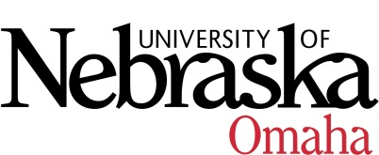

UNIVERSITY OF NEBRASKA AT OMAHA

EDUCATIONAL POLICY ADVISORY COMMITTEE
Minutes

Friday, October 11, 2019

**Reminder – All current courses need to have a master syllabus in Course Inventory Management (CIM)

- Discussion/Announcements
- Minors and Breakdown of Number of Upper Level Courses (attached)
Expectations/guidelines for Minors
- Minors should be in the 12-18 credit hour range – ideally 15 credit hours
- Minimum of 9 credit hours should be upper division courses (3000-4000 level) for 15 credit hour minor – If over the 15 credit hours the majority of credit hours will need to be upper division courses
- Will need to have a justification as to why the minor is under the minimum of 9 credit hours of upper division courses and if under/over 12-18 credit hour range
- Gen Ed and Program Review
- How many hours set aside for general education and program requirements
- Articulation Agreement
- Mid-Plains Community College – AA Graphic Design/UNO BA Studio Art (report item)
- Curriculum
Course Syllabi
New Courses
- CMST 2100 – Introduction to Communication Theory, 3 hrs. - Approved
- CRCJ 4430 – Human Trafficking, 3 hrs. - Approved
- EMGT 4999 – Senior Assessment, 0 hrs. – Rolled back
- GERM 3190 - Listening Comprehension, 3 hrs. – Approved pending minor edits
- NEUR 4960 – Independent Study in Neuroscience, 1-3 hrs. - Approved
- SPAN 8076/SPAN 4070: Hispanic Bilingualism, 3 hrs. – Rolled back

Revised Course
- MUS 8436/4430 – Arranging for Jazz Ensemble, 3 hrs. - Approved
- RELI/WGST 3130 – Women and the Bible, 3 hrs. – Approved pending minor edits

