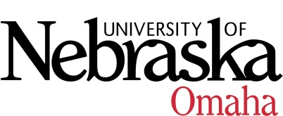

UNIVERSITY OF NEBRASKA AT OMAHA

EDUCATIONAL POLICY ADVISORY COMMITTEE
Minutes
Thursday, January 20, 2022

- Curriculum
Vote Item: Approved
  - Neuroscience Undergraduate Minor

- Course Syllabi

Revised Courses – All Approved
- BIOL 8250: Statistical Analysis and Design for Biological Research – Updated credit hours from 3 to 4 and changed component to Lecture/Lab combo
- CYBR 2930: Special Topics in Cybersecurity – updated from variable credits 1-3 to fix 3 cr hrs
- CYBR 4950: Internship in Cybersecurity – update component from Field Experience to Internship
- CYBR 4990: Independent Study in Cybersecurity – update component from Research to Independent Study
- ISQA 2010: Special Topics in Information Systems and Quantitative Analysis – updated from variable credits 1-3 to set 1
- ITIN 4510: Information Technology Innovation Internship – update component from Independent Study to Internship
- MATH 1370: Applied Algebra and Optimization with Data Analysis – updated credit hours from 4 to 3
- MATH 1960: Calculus II – updated credit hours from 5 to 4

New Courses
- ECON 8246/4240: Labor Economics, 3 cr hrs approved with minor edits
- FREN 8076/4070: Francophone West Africa Cultures, 3 cr hrs approved with minor edits
- GERO 8446/4440: Sociology of Aging, 3 cr hrs Approved
- GERO 8576/4570: Rehabilitative Design, 3 cr hrs rollback for edits
- GERO 8606/4600: Management and Administration of Aging Programs, 3 cr hrs approved with minor edits
- ISQA 8070: Seminar in Management Information Systems, 1 cr hr approved
- ISQA 8090: Seminar in Management Information Systems, 2 cr hrs approved
- PHYS 9920 Topical Seminar in Psychology, 2 cr hrs -Approved

