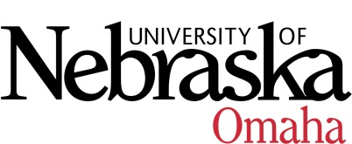

UNIVERSITY OF NEBRASKA AT OMAHA

EDUCATIONAL POLICY ADVISORY COMMITTEE
Agenda

Friday, January 8, 2021
9:00-10:30 AM
Via Zoom

Discussion items:
- Minors for review: Approved
  - Biomechanics
  - Chemistry
  - Mathematics

- Curriculum
Report Items: Approved
- Addition of prefix MLTI – Multidisciplinary Studies

Vote Items: Approved all
- Cross-Sector Collaborative Leadership Undergraduate minor
- Human Performance Undergraduate minor

Course Syllabi
You may access the courses at https://nextcatalog.unomaha.edu/courseleaf/approve. You will be reviewing the courses under Your Role: select EPAC-Associate VC.

Revised Courses
- BIOL 8036/4030: Special Topics in Biology (credit hours changed from 1-3 to 3cr.)
  - Approved
- BIOL 8060: Advanced Topics in Biology (credit hours changed from 1-3 to 3cr.)
  - Approved pending minor edits

New Courses
- BIOL 8685/3680: Biology of Africa, 3 cr.- Rolled back
- BLST 8756/4750: Critical Quantitative Research, 3 cr. Rolled back
- ENGL 8070: Seminar Walt Whitman and Emily Dickinson, 3 cr. Approved pending minor edits
- ENGL 8190: Book-Smart Education in Literatures and Cultures,3 cr Approve pending minor edits
- KINS 4100 Applied Kinesiology, 3 cr. Approved pending minor edits

