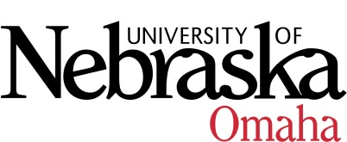

UNIVERSITY OF NEBRASKA AT OMAHA

EDUCATIONAL POLICY ADVISORY COMMITTEE
Agenda

Thursday, December 9, 2021
10:00-11:30 AM
EAB 202/Via Zoom

- Discussion/Announcements
- Course Syllabi
You may access the courses at https://nextcatalog.unomaha.edu/courseleaf/approve. You will be reviewing the courses under Your Role: select EPAC-Associate VC.

Re-review Courses
- CRCJ 8120 Race, Crime and Injustice, 3 cr.

New Courses
- BLST/HIST 2540: Introduction to Egyptian Hieroglyphs, 3 cr.
- ENGL 8446/4440: Bram Stoker: Beyond Dracula, 3 cr.
- INDS 4950: Interdisciplinary Studies: Capstone Course, 3 cr.
- ISQA 2020: Special Topics in Information Systems and Quantitative Analysis, 2 cr.
- ISQA 2030: Special Topics in Information Systems and Quantitative Analysis, 3 cr.
- LLS 3510/PSCI 3510: Immigration Law and Latinos, 3 cr.
- MATH 8956/4950: Topics in theoretical Mathematics, 3 cr.
- NEUR/PSYC 8166/4160: Neuropharmacology, 3 cr.
- PHSI 1010: Introduction to Foundations and Career Paths in Pharmaceutical Sciences, 1 cr.
- WGST 4000: Special Topics: Gender & Sexuality in English Studies, 3 cr.

Meeting Dates September – December - 10-11:30am
- September 9, 2021
- October 14, 2021
- November 11, 2021
- December 9, 2021
Meeting Dates January-May - 9-10:30am
- January 14, 2022
- February 11, 2022
- March 11, 2022
- April 8, 2022
- May 13, 2022

