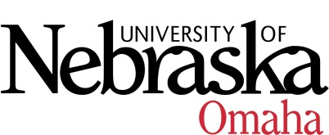

UNIVERSITY OF NEBRASKA AT OMAHA

EDUCATIONAL POLICY ADVISORY COMMITTEE
AGENDA
Friday, November 9, 2018
9:00 AM
202 Eppley Administration Building

- Summary 10.12.18
- Curriculum
  - UNO STEM Trial Center (action item)
  - BA/BS in Medical Humanities (action item)
- Course Syllabi
You may access the courses at https://nextcatalog.unomaha.edu/courseleaf/approve. You will be reviewing the courses under Your Role: select EPAC-Associate VC.

New Courses
- AVN 2100 Flight Team, 1 hr.
- BLST 8716 Brown V. Board of Education, 3 hrs.
- ITIN 8990 Thesis, 1-3 hrs.
- MATH 8626 Iterated Function Systems and Fractals, 3 hrs.
- MUS 1430 Commercial Music Theory I, 3 hrs.
- PSCI 8556 Political Violence, Insurgency, and Terrorism, 3 hrs.
- SPAN 8086 Introduction to Hispanic Linguistics, 3 hrs.
- US 2800 Career Competencies for Professional Success, 3 hrs.

Revised Courses
- MUS 2730 Chamber Orchestra, 0-1
- MUS 8436 Arranging for Jazz Ensemble, 3 hrs. (dual-listing course)
- MUS 8980 Recital, 3 hrs. (changing from variable to fixed)
- PSCI 8366 Authoritarian Regimes, 3 hrs. (reactivating course)

Meeting Dates 9:00-10:30, Eppley Administration Building 202:
Friday, September 14, 2018
Friday, October 12, 2018
Friday, November 9, 2018
Friday, December 7, 2018, EAB 108B (Dual Enrollment Suite)
Friday, January 11, 2019
Friday, February 8, 2019
Friday, March 8, 2019
Friday, April 12, 2019
Friday, May 10, 2019

