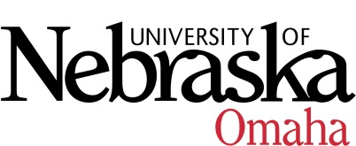

UNIVERSITY OF NEBRASKA AT OMAHA

EDUCATIONAL POLICY ADVISORY COMMITTEE
AGENDA
Friday, January 18, 2019
EAB 202 - 9:00 AM – 10:30 AM

- Summary 12.7.18
- Discussion/Announcements
- Fall 2018 Academic Program Changes (attached)
- Catalog Update
- Complete Syllabus
- Special Topics
- Variable Credit
- Curriculum
- UNO Proposal for Undergraduate Minor in Public Health (action item)
- Course Syllabi
You may access the courses at https://nextcatalog.unomaha.edu/courseleaf/approve. You will be reviewing the courses under Your Role: select EPAC-Associate VC.

New Courses
- BMCH 9870, Musculoskeletal Simulation, 3 hr
- ECON 3310, SQL, Databases, and Data Cleaning for Data Scientists, 3 hr.
- ENGL 8306, Anglo-Saxon Literature, 3 hr.
- MUS 8696, Health and Wellness for Musicians, 3 hr.
- SPAN 3570, Spanish for Healthcare Professionals, 3 hr.
- TED 4700, Education Capstone, 3-6 hr.

Meeting Dates 9:00-10:30, Eppley Administration Building 202:
Friday, September 14, 2018
Friday, October 12, 2018
Friday, November 9, 2018
Friday, December 7, 2018, EAB 108B (Dual Enrollment Suite)
Friday, January 18, 2019
Friday, February 15, 2019 (9:00 am –10:00 am)
Friday, March 8, 2019
Friday, April 12, 2019
Friday, May 10, 2019

