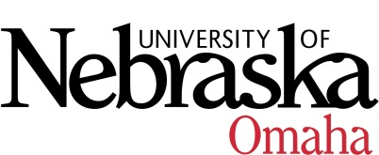

UNIVERSITY OF NEBRASKA AT OMAHA
EDUCATIONAL POLICY ADVISORY COMMITTEE
AGENDA

Friday, November 11, 2016
8:00 AM

- Summary 10-14-16

- Course Syllabi

PLEASE NOTE: NEW URL to CCMS
You may access the system at http://www.unomaha.edu/my/ scroll down to CCMS and click on login. You will be viewing these courses at the VC for Academic Affairs level.

New Courses
- SOWK 4050 Ethnic Diversity and Social Work Practice, 3 hrs.

Revised Courses
- MUS 3640 Music Education Internships, 3 hrs.

Course Syllabi Description/Prerequisites:

New Course(s)

- SOWK 4050 Ethnic Diversity and Social Work Practice, 3 hrs.

Description: This course focuses on effective generalist social work practice with clients of ethnic diversity.

Prerequisites: Undergraduate: BSSW degree students only.
Graduate: MSW degree students only.

Revised Courses

- MUS 3640 Music Education Internships, 3 hrs.

Description: A course designed to link theoretical concepts learned in the classroom to the practical application of "real world" situations and to familiarize students with the profession of music education. Hours completed in this course count as the final practicum as specified by the College of Education Teacher Preparation Program and required by the Nebraska Department of Education for teacher certification.

Prerequisites: MUS 3630

Meeting Dates 8:00-9:30, Eppley Administration Building 202:
Friday, November 11, 2016
Friday, December 9, 2016
Friday, January 13, 2017
Friday, February 10, 2017
Friday, March 10, 2017
Friday, April 14, 2017
Friday, May 12, 2017

