University of Nebraska at Omaha – Educational Policy Advisory Committee

Guidelines for writing effective student learning outcomes (SLO) – May, 2019
All faculty members create course syllabi to define course content and expectations. An important element of creating a course (and its syllabus) is determining the student learning outcomes (SLO). A student learning outcome is a formal statement detailing what a student/learner should know or be able to do at the conclusion of the course or learning intervention. A learning outcome may be a behavioral or cognitive demonstration of mastery of course content. Effective learning outcomes are specific, observable, and measurable actions done by the student/learner not by the teacher/professor.
Every course syllabus must contain appropriate SLOs. It is suggested that for each credit hour, there be 1 or 2 learning objectives. In general, most 3 credit hour courses would have between 3-6 SLOs. Courses that are tied to specific professional practice guidelines in the discipline may incorporate standard SLOs as required by the professional accrediting body.
While there are no hard and fast rules, undergraduate courses at the 1000 and 2000 levels will likely focus on the lower levels in the taxonomy (remember, understand, and apply). Undergraduate courses at the 3000 and 4000 levels would likely focus on middle levels in the taxonomy (apply, analyze, and evaluate). Graduate level courses would likely focus on higher levels of the taxonomy (analyze, evaluate, and create). Dual-listed courses should therefore have different learning objectives for the undergraduate and graduate courses and the syllabus should reflect those SLOs.
SLOs may focus on cognitive, behavioral/psychomotor, or attitudinal outcomes that link to overall program learning outcomes within a course of study. The National Institute for Learning Outcomes Assessment provides comprehensive information relative to SLOs along with many institutional examples.
Utilizing the six levels of Bloom’s Taxonomy (below) is an excellent way to ensure that SLOs are action-focused, learner-centered, and written at the appropriate level for the course. SLO statements should be written using verbs that describe exactly what the student/learner will be able to do at the end of the course. Before writing a SLO, it is a good idea to identify at which level within the taxonomy you are working. Doing so will clarify student actions as well as helping you to incorporate relevant verbs (see attached list). Think about the last day of the semester and what you would expect students to demonstrate regarding mastery of course content. Consider what specific knowledge or skills they need to carry forward to subsequent courses that are based on the present course content. These are ways to ensure that you have appropriate, effective SLOs for each course.

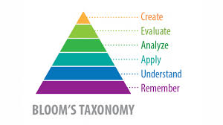
The following YouTube presentations on Bloom’s Taxonomy may be helpful to those who are looking for additional help in understanding the framework and its application.
https://www.youtube.com/watch?v=ayefSTAnCR8
https://www.youtube.com/watch?v=4DgkLV9h69Q
A list of level-based action verbs is provided at the end of this document.
Examples of well-written SLOs follow.
General Psychology course (Texas Tech University)
At the end of the course, students should be able to:
1. Identify and define basic terms and concepts which are needed for advanced courses in psychology
2. Outline the scientific method as it is used by psychologists
3. Apply the principles of psychology to practical problems
4. Compare and contrast the multiple determinants of human behavior
5. Analyze current research findings in the areas of psychology, perception, and learning
6. Distinguish between healthy and unhealthy physical, mental, and emotional patterns

Plant and Soil Sciences course (Texas Tech University)
At the end of the course, students should be able to:
1. Label the parts of a plant
2. Define the terms used in plant growth and reproduction
3. Explain transpiration, respiration, and photosynthesis
4. Calculate the germination rates of various seeds
5. Identify soil texture and structure from soil samples
6. List the primary, secondary, and micro nutrients present in soil
7. Identify and describe land capability classes ad their uses

Undergraduate Economics BA/BS/BBA (Georgia State University)

At the end of the course, students will be able to:
1. Demonstrate knowledge of basic theories, concepts, and analytical methods of microeconomics and macroeconomics
2. Apply theories, concepts, and analytical methods of microeconomics and macroeconomics to specific fields of economics
3. Identify the relevant benefits and costs to consider when comparing policy choices.
4. Communicate, using appropriate writing and oral conventions, basic economic theories, concepts, analytical methods, and policy choices

Graduate Social Work MSW (Georgia State University)

At the end of the course, students will be able to:

1. Evaluate and integrate multiple sources of knowledge, including research-based knowledge and practice-generated knowledge
2. Engage in community partnerships that are responsive to diversity and difference.
3. Analyze how differential power and privilege shape communities and society
4. Provide leadership in promoting changes to improve community wellbeing
5. Develop, monitor, and/or strengthen collaborative relationships that focus on building healthy communities

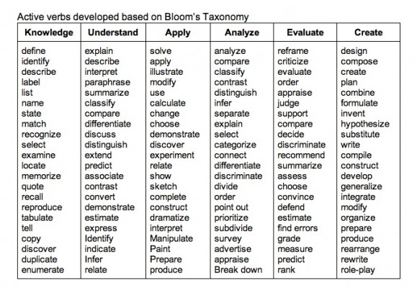
Retrieved from http://www.teachthought.com/learning/249-blooms-taxonomy-verbs-for-critical-thinking
References

Bloom, B.S. (1956). Taxonomy of Educational Objectives, Handbook I: The Cognitive Domain. New York, NY: David McKay Co Inc.

Georgia State University, https://oie.gsu.edu/files/2014/07/GSU-Program-SLOs.pdf

National Institute for Learning Outcomes Assessment, http://www.learningoutcomesassessment.org/TFComponentSLOS.htm

Retrieved from http://www.teachthought.com/learning/249-blooms-taxonomy-verbs-for-critical-thinking/

Texas Tech University, https://www.depts.ttu.edu/opa/resources/docs/Writing_Learning_Outcomes_Handbook3.pdf

