UNO ACADEMIC PROGRAM ASSESSMENT ONLINE SUBMISSION SYSTEM INSTRUCTIONS
Table of Contents
Logging In 4
Finding Your Report(s) 5
Completing a Non-Accredited Report 6
Beginning 6
Section I: SLOs 7
• SLO Summary 7
▪ Adding a New SLO 7
▪ Importing a SLO From a Previous Report 8
▪ Editing or Deleting a SLO 10
▪ Other Options in the SLOs Section 10
• Communication to Stakeholders 11
• Additional Comments 12
Section II: Assessments 13
• Assessment Summary 13
▪ Adding a New Assessment 13
▪ Importing a Previous Assessment 14
▪ Editing or Deleting an Assessment Method 16
▪ Adding a Supplement (e.g., Rubric) 17
▪ Other Options in the Assessment Methods Section 17
• Additional Comments 17
Section III: Data 18
• Data Table 18
▪ Add Data 18
▪ Add Aggregate 18
▪ Editing or Deleting Data 19
• Supplements 19
• SLO Status 19
• Describe How Results Are Communicated Within the Program 20
• Additional Comments 21
Section IV: Decisions & Actions 21
• Decisions and Actions Table 21
• Additional Comments 22
Report Supplements 22
Preview & Submit 22
Completing an Accredited Report 24
Beginning 24
Section I: SLOs 24
• SLO Summary 24
▪ Adding a New SLO 24
▪ Importing a SLO From a Previous Report 26
▪ Editing or Deleting a SLO 27
▪ Other Options in the SLOs Section 28
• Additional Comments 28
Section II: Assessments 29
• Assessment Summary 29
▪ Adding a New Assessment 29
▪ Importing a Previous Assessment 30
▪ Editing or Deleting an Assessment Method 31
▪ Adding or Importing a Supplement (e.g., Rubric) 31
• Additional Comments 32
Section III: Data 32
• Supplements 32
• SLO Status 32
• Additional Comments 33
Section IV: Decisions & Actions 33
• Decisions and Actions Table 33
• Additional Comments 34
Report Supplements 34
Preview & Submit 35
Frequently Asked Questions 37
What do I do if I assess two programs in one report (e.g., BA/BS or MA/MS in the same report)? 37
If I have two or more SLOs that use the same assessment, do I have to add all the assessment information using “Add Assessment” multiple times? 37
What happens if my SLO has two or more measures? 38
What if my data looks different than what can be added into the data table? 39
What does the blue “Clear Overrides” button do in the “Data Table” portion of “Section III: Data?” 39
What if I want to cancel without saving when adding an SLO, assessment measure, and so on? 39
What if I do not use threshold metrics to analyze my assessment data? 40
I have additional questions that are not answered in this guide. 41

Logging In
- Access the UNO Academic Program Assessment Online Submission System Login page. If the hyperlink is not working, please copy this web address into your web browser:
https://ist-uno-acad-assess-prd.unomaha.edu/
- Click “Login” on the welcome page (should be directly under Welcome!).

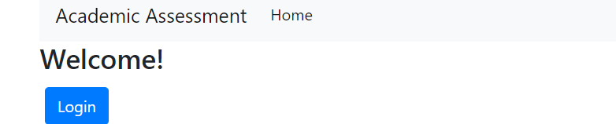
- Enter your department’s username and password (provided in an email by UNO Academic Program Assessment). Please contact programassessment@unomaha.edu if you need a reminder of your username and/or password.
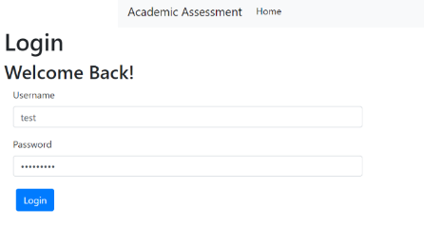

Finding Your Report(s)
- Under “Department Reports To-Do,” a list of your reports due for the current assessment cycle should be provided.
- Click the blue “Start” button next to the report name to begin filling out the report.
  - GR stands for graduate report.
  - UG stands for undergraduate report.
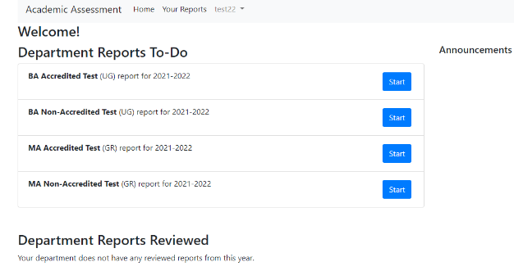
- If a report is missing from your to-do list, please contact programassessment@unomaha.edu.

Completing a Non-Accredited Report

Beginning
- In the author information section, please provide the name(s) of who is completing the report.
- In the date range of reported data, please provide the date range of when the data was collected (e.g., 2018-2020).
- To receive the abbreviated accredited report form, check the program is accredited box. If this box is not checked, you will receive the non-accredited report form. The accredited report is for program-level accreditation and is for programs who are evaluated by an external accrediting body (e.g., AACSB, ABET, AAQEP, etc.). At the institution-level, UNO is accredited by the Higher Learning Commission (HLC), but this is not the same as program-level accreditation.
- If your SLOs are reviewed by an accrediting body, check the SLOs are reviewed by accrediting body box. This checkbox is for programs whose accrediting bodies (e.g., AACSB) routinely review their SLOs whether annually, bi-annually, every 5 years, etc.
- If your SLOs are established by an accrediting body, check the SLOs are established by accrediting body box. This checkbox is for programs whose accrediting bodies (e.g., ABET) require programs use specific SLOs/guidelines that cannot be changed.
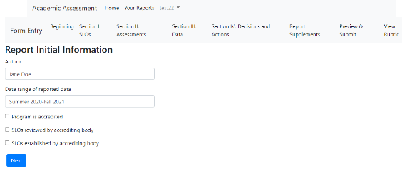

Section I: SLOs

SLO Summary

Adding a New SLO
- Click the blue “Add SLO” button to create a new SLO (should be directly under “SLO Summary”).
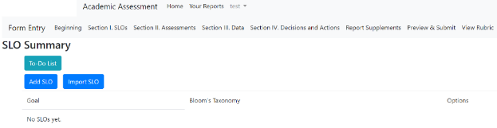

- Type the new SLO in the text box.
- Indicate the highest Bloom’s Taxonomy level using the drop-down menu.
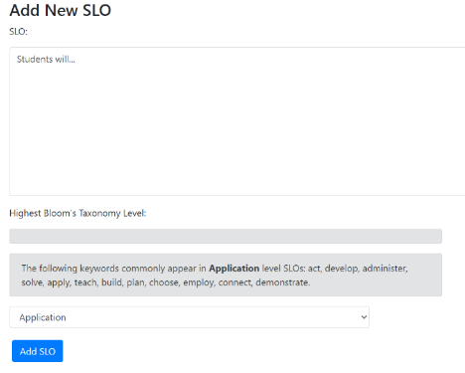

- For graduate programs only, indicate the graduate-level goal(s) the SLO maps onto by clicking the boxes.
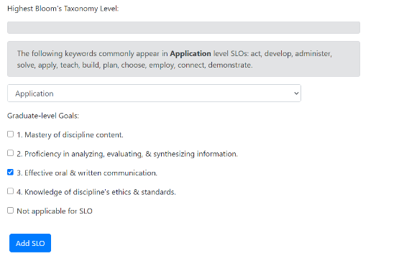
- When finished, click the blue “Add SLO” button to create the new SLO.

Importing a SLO From a Previous Report
- Click the blue “Import SLO” button to import a previous SLO (should be directly under “SLO Summary”).
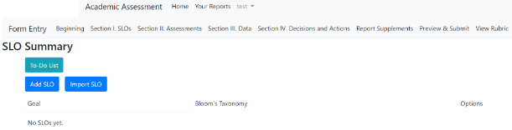
- First, complete the “Search for SLOs” section:
  - Indicate the degree program you wish to draw the previous SLO from using the drop-down menu.
  - Indicate the report year you wish to draw the previous SLO from using the drop-down menu.
  - Click the blue “Search for SLOs” button.
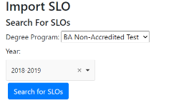
- Then complete the “Select SLOs to Import” section:
  - Click the gray box under “SLOs to Import.” If the first step was completed, a drop-down menu of SLOs from the selected previous report should appear. Select one or more SLOs to import.
  - If the previous SLOs assessments also have not changed, click the “Also import assessments with SLO” box to import the previous report’s assessments.
- When finished, click the blue “Add SLOs” button to import the previous SLO(s).
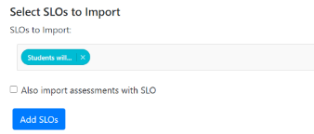
- WARNING: Importing an SLO means that certain areas cannot be edited (e.g., Bloom’s level or Grad SLOs) in either the original form or the imported form.
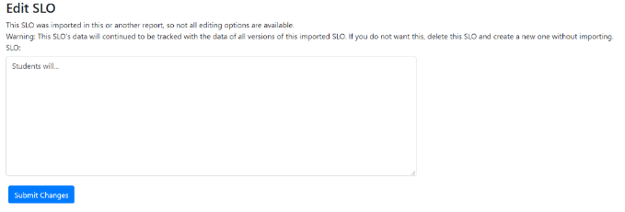

Editing or Deleting a SLO
- Click the blue “Edit SLO” button on the right side of a SLO (in the options column) to edit a SLO.
- Click the blue “Delete SLO” button on the right side of a SLO (in the options column) to permanently remove a SLO.
- WARNING: Deleting a SLO will delete all assessments tied to that SLO.
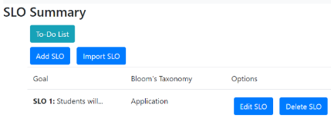

Other Options in the SLOs Section
- The blue “Add New Assessment” button on the right side of a SLO (in the options column) is where you can add a new assessment method for that SLO. You can also add assessments in the “Section II: Assessments” portion of the “Completing a Non-Accredited Report” section. For further information on how to add a new assessment for an SLO, refer to the “Section II: Assessments” portion in this guide.
- The blue “Import Assessment” button on the right side of a SLO (in the options column) is where you can import a previously added assessment method for that SLO. You can also import assessments in the “Section II: Assessments” portion of the “Completing a Non-Accredited Report” section. For further information on how to import a previous assessment for an SLO, refer to the “Section II: Assessments” portion in this guide.
- The blue “Decisions and Actions” button on the right side of a SLO (in the options column) is where you can type in the decisions and actions your program has made about a particular SLO. You can also add decisions and actions in the “Section IV: Decisions and Actions” portion of the “Completing a Non-Accredited Report” section. For further information on how to add decisions and actions for an SLO, refer to the “Section IV: Decisions and Actions” portion in this guide.
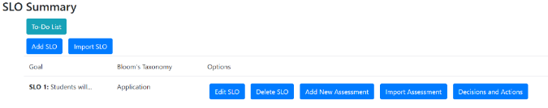

Communication to Stakeholders
- Click the blue “Edit” button next to “Communication to Stakeholders” to complete this section. When finished, click the blue “Save” button.
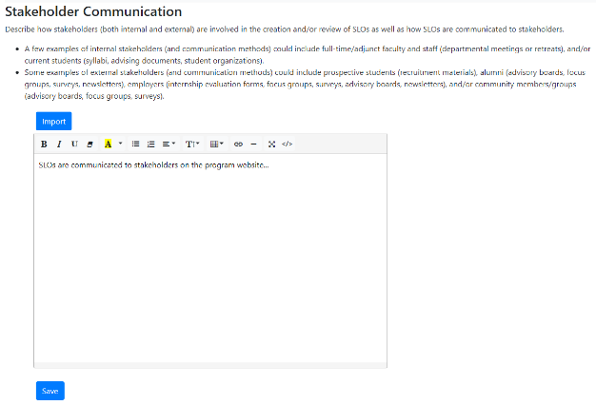

- If you want to import this section from a previous report, click the blue “Import” button after clicking the “Edit” button from the previous step.
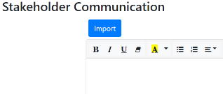

  - First, complete the “Search From Past Reports” section:
    - Indicate the degree program you wish to draw the previous information from using the drop-down menu.
    - Indicate the report year you wish to draw the previous information from using the drop-down menu.
    - Click the blue “Search” button.
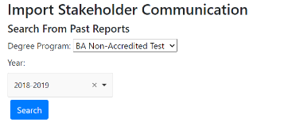
  - Then complete the “Select Stakeholders to Import” section:
    - Click the gray box under “Stakeholder Communication Methods”. If the first step was completed, a drop-down menu of previous information from the selected previous report should appear. Select what you want to import.
    - When finished, click the blue “Import” button to import previous information.
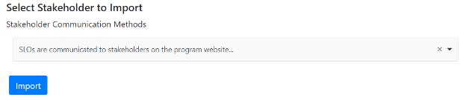

Additional Comments
  - Click the blue “Edit” button next to “Additional Comments” to add any extra information for “Section I: SLOs” that the AAC reviewers might find useful. When finished, click the blue “Save” button.
  - If you need any further guidance on completing “Section I: SLOs,” please reach out to programassessment@unomaha.edu.
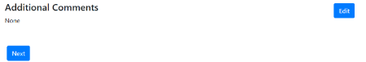

Section II: Assessments

Assessment Summary

Adding a New Assessment
- Click the blue “Add Assessment” button in the top left corner to create a new assessment.
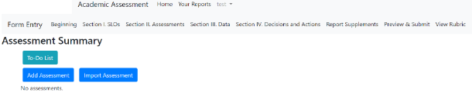
- Click the SLO from the drop-down box this assessment measures.
- Indicate the title of the assessment.
- Briefly, describe how this measure aligns with the selected SLO.
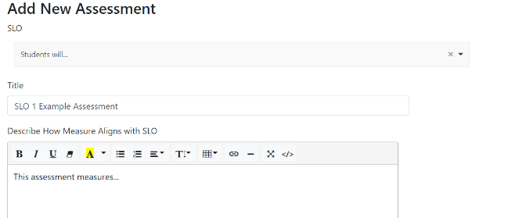
- Click the domain box(es) this assessment relates to.
- Indicate whether the assessment is a direct measure or indirect measure using the drop-down menu.
- Indicate the point in the program this assessment is administered using the drop-down menu.
- Indicate where this assessment occurs (e.g., the course number).
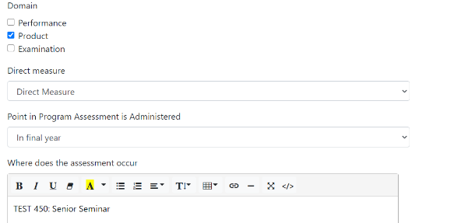
- Indicate the population measured using the drop-down menu.
- Indicate the frequency of data collection using the drop-down menu.
- Indicate the proficiency threshold (if you use threshold metrics). If you do not use threshold metrics, please see the “What if I do not use threshold metrics to analyze my assessment data?” in the Frequently Asked Questions section.
- Indicate the proficiency target (e.g., 90%).
- When finished, click the blue “Add Assessment” button to create the new assessment.
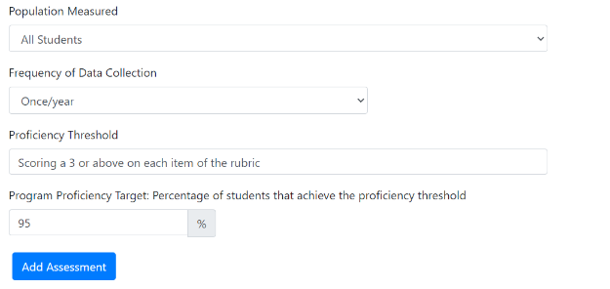

Importing a Previous Assessment
- Click the blue “Import Assessment” button in the top left corner to import a previous assessment from a prior report OR a prior SLO (e.g., SLO 1 and 3 use the same assessment measure). See the above screenshot under “Adding a New Assessment.”
- First, complete the “Search for Assessments” section:
  - Indicate the degree program you wish to draw the previous assessment from using the drop-down menu.
  - Indicate the report year you wish to draw the previous assessment from using the drop-down menu.
  - Indicate the specific SLO you wish to draw an assessment from. You can also choose any if it does not matter.
  - Click the blue “Search for Assessments” button.
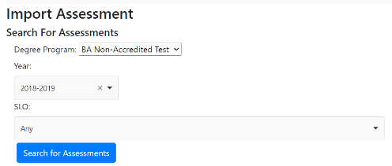
- Then complete the “Select Assessments to Import” section:
  - Click the assessment title under “Assessment” that you want to import.
  - Indicate which SLO this assessment measures using the drop-down menu.
- When finished, click the blue “Add Assessments” button to import the previous assessments.
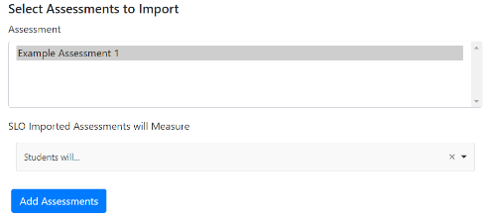
- WARNING: Importing an assessment means that the certain areas cannot edited (e.g., title of assessment) in either the original form or the imported form.
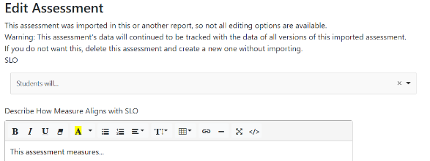

Editing or Deleting an Assessment Method
- Click the blue “Edit Assessment” button at the bottom of an assessment (in the options row) to edit an assessment.
- Click the blue “Delete Assessment” button at the bottom of an assessment (in the options row) to delete an assessment.
- WARNING: Deleting an assessment will delete all data tied to that assessment.
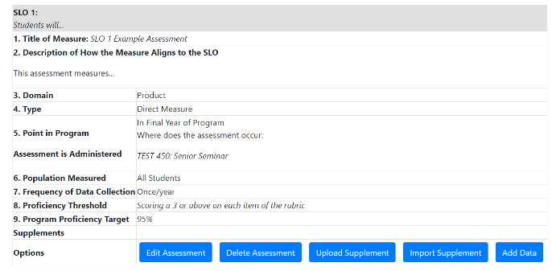

Adding a Supplement (e.g., Rubric)
- Click the blue “Upload Supplement” button at the bottom of an assessment (in the options row) to upload a rubric or additional supplement (see the above screenshot under “Editing or Deleting an Assessment Method”).
- Choose the file you wish to upload.
- When finished, click the blue “Upload” button.
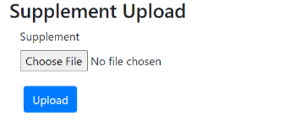

Other Options in the Assessment Methods Section
- The blue “Import Supplement” button at the bottom of an assessment (in the options row) is where you can upload a supplement from a previous report (see the above screenshot under “Editing or Deleting an Assessment Method”). The process is very similar to the “Adding a Previous Assessment” section above. Refer there, for further information.
- The blue “Add Data” button at the bottom of an assessment (in the options row) is where you can upload data for that assessment (see the above screenshot under “Editing or Deleting an Assessment Method”). You can also add data in the “Section III: Data” portion of the “Completing a Non-Accredited Report” section. For further information on how to add data for an assessment, refer to the “Section III: Data” portion of this guide.

Additional Comments
  - Click the blue “Edit” button next to “Additional Comments” to add any extra information for “Section II: Assessments” that the AAC reviewers might find useful. When finished, click the blue “Save” button.
  - If you need any further guidance on completing “Section II: Assessments,” please reach out to programassessment@unomaha.edu.
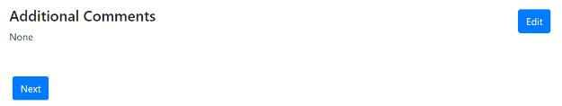

Section III: Data

Data Table

Add Data
- Click the blue “Add Data” button next to each SLO measure to add data.
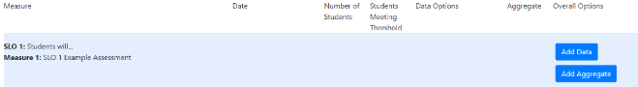
- Indicate the data collection range.
- Indicate the number of students sampled.
- Indicate the percentage of students that met or exceeded the threshold proficiency.
- When finished, click the blue “Add Data” button to add data.
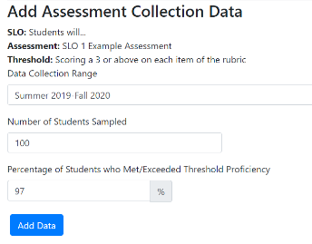

Add Aggregate
- Click the optional blue “Add Aggregate” button next to each SLO measure to aggregate all the data for this assessment into one number (see the above screenshot under “Add Data”).
- Indicate the aggregate percentage.
- When finished, click the blue “Save” button to create an aggregate.
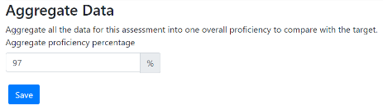

Editing or Deleting Data
- Click the blue “Edit Data” button in the middle of the SLO row (in the data options column) to edit the SLO’s data.
- Click the blue “Delete Data” button in the middle of the SLO row (in the data options column) to delete the SLO’s data.
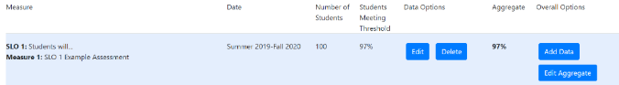

Supplements
- Click the blue “Add Supplement” button to upload a data supplement (e.g., a different table or chart used to display data).
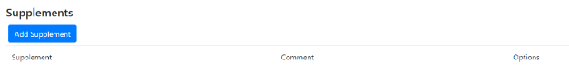
- Indicate what the supplement is describing in the comment section.
- Choose the file you wish to upload.
- When finished, click the blue “Upload” button.
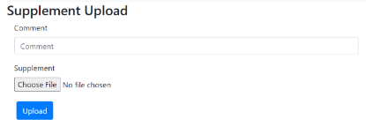

SLO Status
- Whether an SLO is met, partially met, not met, or unknown is automatically updated if data is entered using the “Add Data” button.
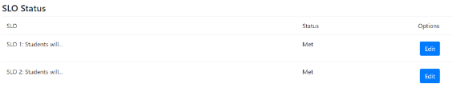
- To edit the status, click the blue “Edit” button next to the SLO, and indicate the updated status. When finished, click the blue “Save” button to implement the change.
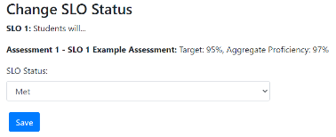

Describe How Results Are Communicated Within the Program
- Click the blue “Edit” button to describe how results are communicated within the program.
describes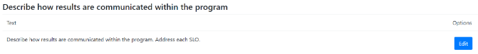
- Type in the information. When finished, click the blue “Save” button.
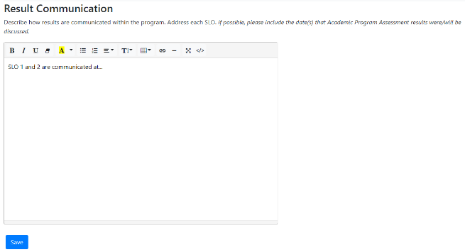

Additional Comments
  - Click the blue “Edit” button next to “Additional Comments” to add any extra information for “Section III: Data” that the AAC reviewers might find useful. When finished, click the blue “Save” button.
  - If you need any further guidance on completing “Section III: Data,” please reach out to programassessment@unomaha.edu.
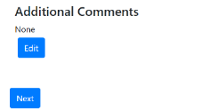

Section IV: Decisions & Actions

Decisions and Actions Table
- Click the blue “Add” button next to each SLO to add in comments about decisions and actions being made.
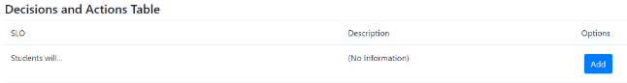
- Type in the information. When finished, click the blue “Save” button.
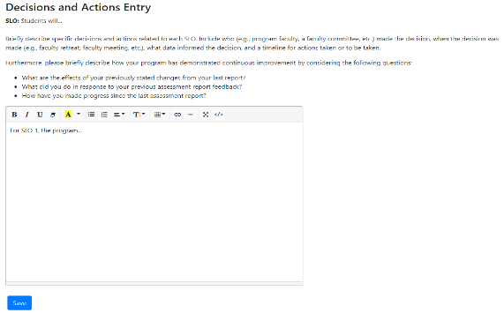

Additional Comments
  - Click the blue “Edit” button next to “Additional Comments” to add any extra information for “Section IV: Decisions and Actions” that the AAC reviewers might find useful. When finished, click the blue “Save” button.
  - If you need any further guidance on completing “Section IV: Decisions and Actions,” please reach out to programassessment@unomaha.edu.
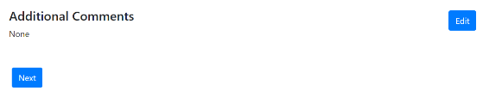

Report Supplements
- If you wish to add a supplement to your overall report, click the blue “Add Supplement to Report” button.
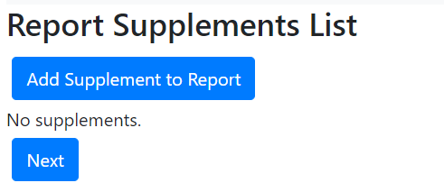
- Choose the file you wish to upload.
- When finished, click the blue “Add” button.
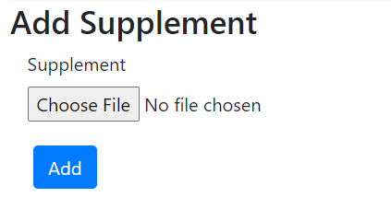

Preview & Submit
- Review the report either on the webpage or by clicking the blue “Report PDF (with supplements)” or “Report PDF (without supplements)” buttons at the top. You may download a PDF file to keep in your records.
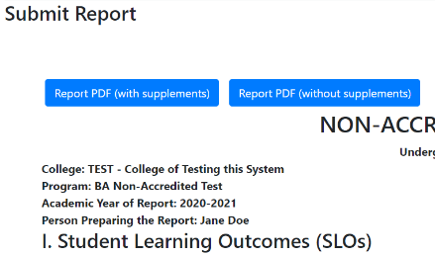
- If any changes need to be made, go to that section in the report and implement those changes.
- When the report is ready to be submitted to the AAC, click the blue “Submit Report to AAC” button in the top right corner.
- If you need any further guidance on completing the non-accredited report, please check the “Frequently Asked Questions” section at the end of the guide and/or reach out to programassessment@unomaha.edu.

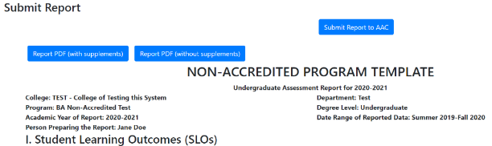

Completing an Accredited Report

Beginning
- In the author information section, please provide the name(s) of who is completing the report.
- In the date range of reported data, please provide the date range of when the data was collected (e.g., 2018-2020).
- To receive the abbreviated accredited report form, check the program is accredited box. If this box is not checked, you will receive the non-accredited report form. The accredited report is for program-level accreditation and is for programs who are evaluated by an external accrediting body (e.g., AACSB, ABET, AAQEP, etc.). At the institution-level, UNO is accredited by the Higher Learning Commission (HLC), but this is not the same as program-level accreditation.
- If your SLOs are reviewed by an accrediting body, check the SLOs are reviewed by accrediting body box. This checkbox is for programs whose accrediting bodies (e.g., AACSB) routinely review their SLOs whether annually, bi-annually, every 5 years, etc.
- If your SLOs are established by an accrediting body, check the SLOs are established by accrediting body box. This checkbox is for programs whose accrediting bodies (e.g., ABET) require programs use specific SLOs/guidelines that cannot be changed.
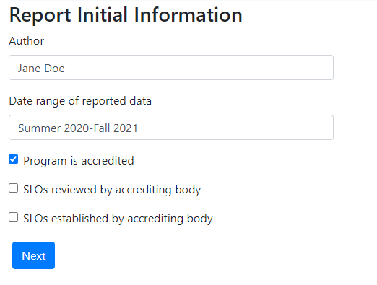

Section I: SLOs
- SLO Summary
- Adding a New SLO
- Click the blue “Add SLO” button to create a new SLO (should be directly under “SLO Summary”).

- Type the new SLO in the text box.
- Indicate the highest Bloom’s Taxonomy level using the drop-down menu.
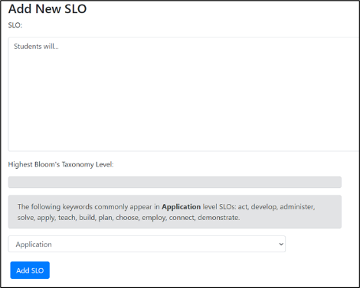

- For graduate programs only, indicate the graduate-level goal(s) the SLO maps onto by clicking the boxes.
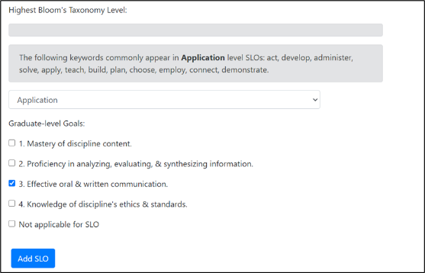
- When finished, click the blue “Add SLO” button to create the new SLO.

- Importing a SLO From a Previous Report
- Click the blue “Import SLO” button to import a previous SLO(should be directly under “SLO Summary”).
- First, complete the “Search for SLOs” section:
  - Indicate the degree program you wish to draw the previous SLO from using the drop-down menu.
  - Indicate the report year you wish to draw the previous SLO from using the drop-down menu.
  - Click the blue “Search for SLOs” button.
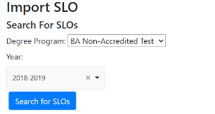

- Then complete the “Select SLOs to Import” section:
  - Click the gray box under “SLOs to Import.” If the first step was completed, a drop-down menu of SLOs from the selected previous report should appear. Select one or more SLOs to import.
  - If the previous SLOs assessments also have not changed, click the “Also import assessments with SLO” box to import the previous report’s assessments.
- When finished, click the blue “Add SLOs” button to import the previous SLO(s).
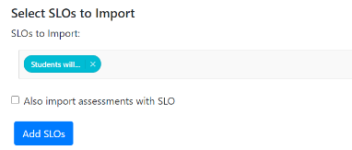

- WARNING: Importing an SLO means that certain areas cannot be edited (e.g., Bloom’s level or Grad SLOs) in either the original form or the imported form.
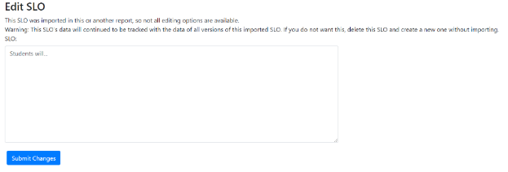

- Editing or Deleting a SLO
- Click the blue “Edit SLO” button on the right side of a SLO (in the options column) to edit a SLO.
- Click the blue “Delete SLO” button on the right side of a SLO (in the options column) to permanently remove a SLO.
- WARNING: Deleting a SLO will delete all assessments tied to that SLO.

- Other Options in the SLOs Section
- The blue “Add New Assessment” button on the right side of a SLO (in the options column) is where you can add a new assessment method for that SLO. You can also add assessments in the “Section II: Assessments” portion of the “Completing a Non-Accredited Report” section. For further information on how to add a new assessment for an SLO, refer to the “Section II: Assessments” portion in this guide.
- The blue “Import Assessment” button on the right side of a SLO (in the options column) is where you can import a previously added assessment method for that SLO. You can also import assessments in the “Section II: Assessments” portion of the “Completing a Non-Accredited Report” section. For further information on how to import a previous assessment for an SLO, refer to the “Section II: Assessments” portion in this guide.
- The blue “Decisions and Actions” button on the right side of a SLO (in the options column) is where you can type in the decisions and actions your program has made about a particular SLO. You can also add decisions and actions in the “Section IV: Decisions and Actions” portion of the “Completing a Non-Accredited Report” section. For further information on how to add decisions and actions for an SLO, refer to the “Section IV: Decisions and Actions” portion in this guide.
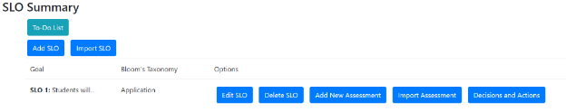

- Additional Comments
  - Click the blue “Edit” button next to “Additional Comments” to add any extra information for “Section I: SLOs” that the AAC reviewers might find useful. When finished, click the blue “Save” button.
  - If you need any further guidance on completing “Section I: SLOs,” please reach out to programassessment@unomaha.edu.
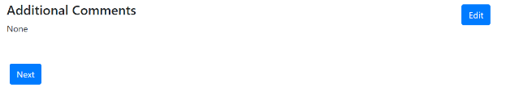

Section II: Assessments
- Assessment Summary
  - Adding a New Assessment
- Click the blue “Add Assessment” button in the top left corner to create a new assessment.
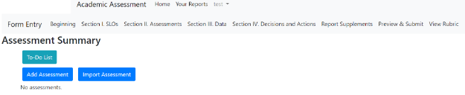
- Click the SLO from the drop-down box this assessment measures.
- Indicate the title of the assessment.
- Click the domain box(es) this assessment relates to.
- Indicate the frequency of data collection using the drop-down menu.
- When finished, click the blue “Add Assessment” button to create the new assessment.
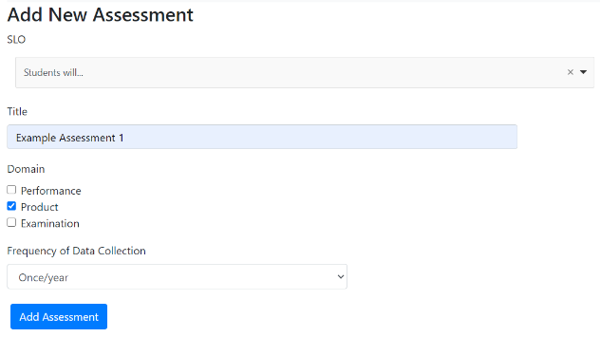

  - Importing a Previous Assessment
- Click the blue “Import Assessment” button in the top left corner to import a previous assessment from a prior report OR a prior SLO (e.g., SLO 1 and 3 use the same assessment measure). See the above screenshot under “Adding a New Assessment.”
- First, complete the “Search for Assessments” section:
  - Indicate the degree program you wish to draw the previous assessment from using the drop-down menu.
  - Indicate the report year you wish to draw the previous assessment from using the drop-down menu.
  - Click the blue “Search for Assessments” button.
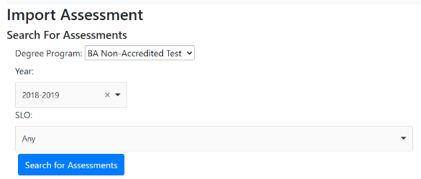
- Then complete the “Select Assessments to Import” section:
  - Click the assessment title under “Assessment” that you want to import.
  - Indicate which SLO this assessment measures using the drop-down menu.
- When finished, click the blue “Add Assessments” button to import the previous assessments.
- WARNING: Importing an assessment means that the certain areas cannot edited (e.g., title of assessment) in either the original form or the imported form.

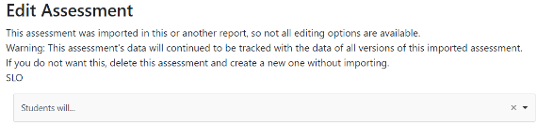

  - Editing or Deleting an Assessment Method
- Click the blue “Edit Assessment” button at the bottom of an assessment (in the options row) to edit an assessment.
- Click the blue “Delete Assessment” button at the bottom of an assessment (in the options row) to delete an assessment.
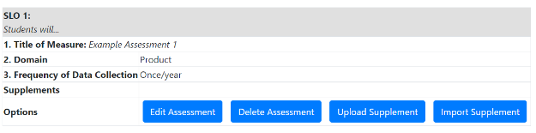
  - Adding or Importing a Supplement (e.g., Rubric)
- Adding a Supplement
  - Click the blue “Upload Supplement” button at the bottom of an assessment (in the options row) to upload a rubric or additional supplement (see the above screenshot under “Editing or Deleting an Assessment Method”).
  - Choose the file you wish to upload.
  - When finished, click the blue “Upload” button.
- The blue “Import Supplement” button at the bottom of an assessment (in the options row) is where you can upload a supplement from a previous report. The process is very similar to the “Adding a Previous Assessment” section above. Refer there, for further information.

- Additional Comments
  - Click the blue “Edit” button next to “Additional Comments” to add any extra information for “Section II: Assessments” that the AAC reviewers might find useful. When finished, click the blue “Save” button.
  - If you need any further guidance on completing “Section II: Assessments,” please reach out to programassessment@unomaha.edu.

Section III: Data
- Supplements
- Click the blue “Add Supplement” button to upload a data supplement (e.g., a different table or chart used to display data.
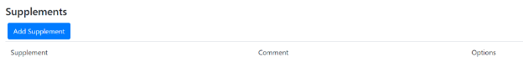
- Indicate what the supplement is describing in the comment section.
- Choose the file you wish to upload.
- When finished, click the blue “Upload” button.
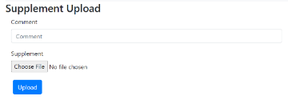

- SLO Status
- To edit the status, click the blue “Edit” button next to the SLO, and indicate the updated status.
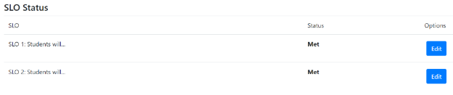

- When finished, click the blue “Save” button to implement the change.
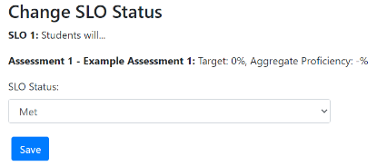

- Additional Comments
  - Click the blue “Edit” button next to “Additional Comments” to add any extra information for “Section III: Data” that the AAC reviewers might find useful. When finished, click the blue “Save” button.
  - If you need any further guidance on completing “Section III: Data,” please reach out to programassessment@unomaha.edu.
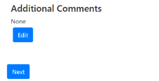

Section IV: Decisions & Actions
- Decisions and Actions Table
- Click the blue “Add” button next to each SLO to add in comments about decisions and actions being made.
- Type in the information. When finished, click the blue “Save” button.
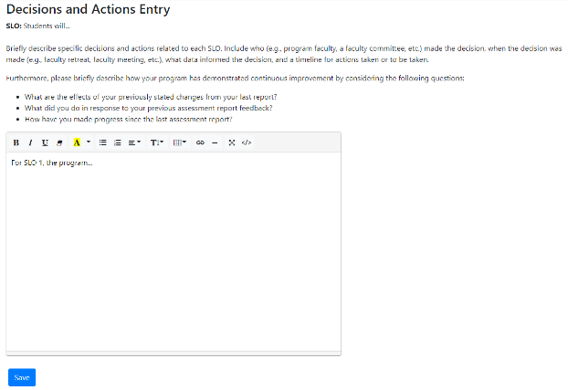

- Additional Comments
  - Click the blue “Edit” button next to “Additional Comments” to add any extra information for “Section IV: Decisions and Actions” that the AAC reviewers might find useful. When finished, click the blue “Save” button.
  - If you need any further guidance on completing “Section IV: Decisions and Actions,” please reach out to programassessment@unomaha.edu.

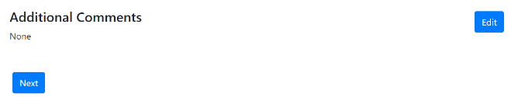

Report Supplements
- If you wish to add a supplement to your overall report, click the blue “Add Supplement to Report” button.
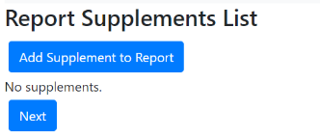
- Choose the file you wish to upload.
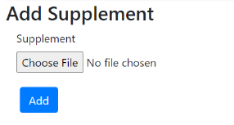
- When finished, click the blue “Add” button.

Preview & Submit
- Review the report either on the webpage or by clicking the blue “Report PDF (with supplements)” or “Report PDF (without supplements)” buttons at the top. You may download a PDF file to keep in your records.
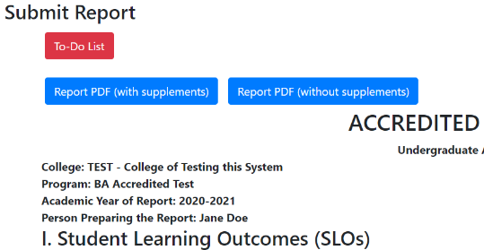

- If any changes need to be made, go to that section in the report and implement those changes.
- When the report is ready to be submitted to the AAC, click the blue “Submit Report to AAC” button in the top right corner.
- If you need any further guidance on completing the accredited report, please check the “Frequently Asked Questions” section at the end of the guide and/or reach out to programassessment@unomaha.edu.
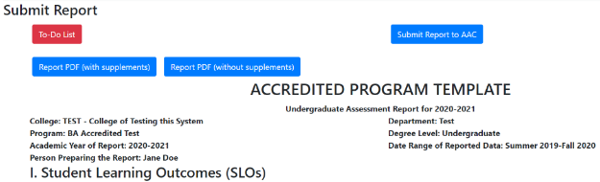

Frequently Asked Questions

What do I do if I assess two programs in one report (e.g., BA/BS or MA/MS in the same report)?
Although separate reports will be assigned to you for the BA and BS (or MA/MS), you do not have to complete the same report twice if the programs happen to be analyzed together. Simply, complete the report for the BA or (MA). In the “Additional Comments” portion of “Section I: SLOs,” simply indicate that this is the report for both the BA/BS (or MA/MS).
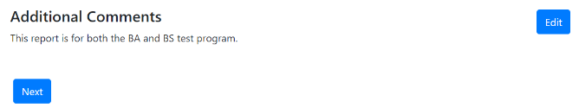

If I have two or more SLOs that use the same assessment, do I have to add all the assessment information using “Add Assessment” multiple times?
No, you do not have to keep re-adding the same assessment. If you added a new assessment for SLO 1 that SLO 2 also uses, click the blue “Import Assessment” button. In the “Select Assessment to Import” section, click the assessment title you wish to import and click the SLO you wish to import that assessment into. When finished, click the blue “Add Assessments” button. You can edit parts of the assessment (e.g., the “how does this measure align to the SLO” section), by clicking “Edit Assessment” in the options under the newly imported assessment. However, you cannot change the edit the name of an imported assessment.
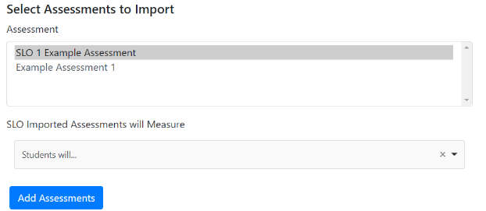

What happens if my SLO has two or more measures?
You can upload multiple measures for the same SLO. After adding the first measure, click the “Add Assessment” or “Import Assessment” buttons, and indicate the same SLO you previously just did. The system will automatically include them as different measures as long as each measure has a unique title. Both Measures will occur on in the data table in “Section III: Data.”
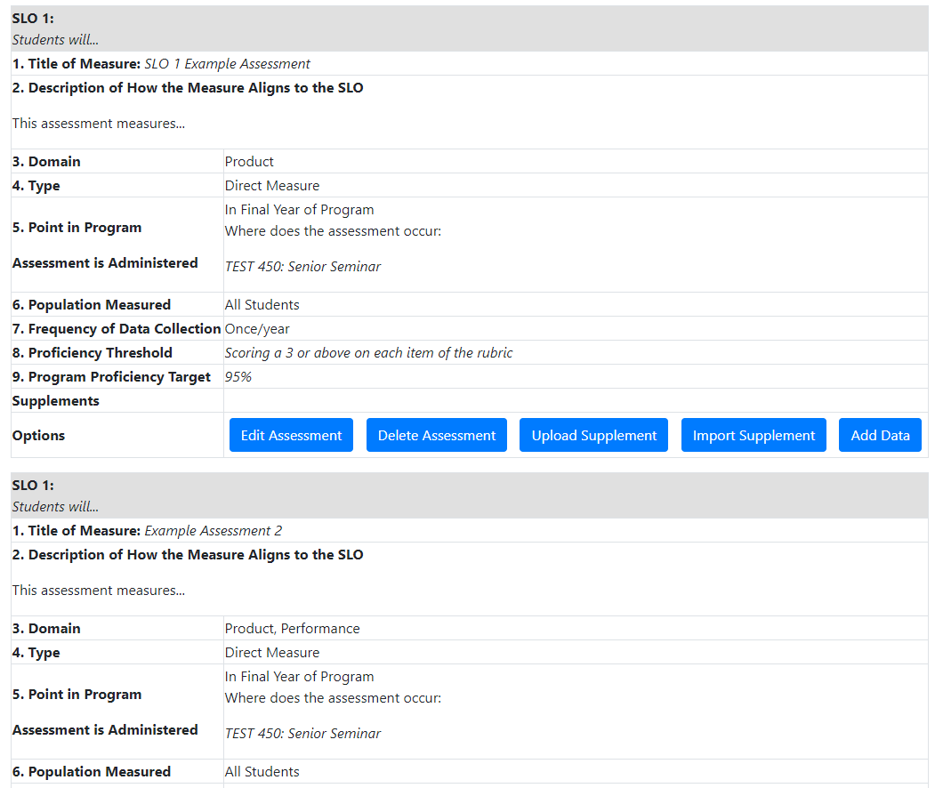
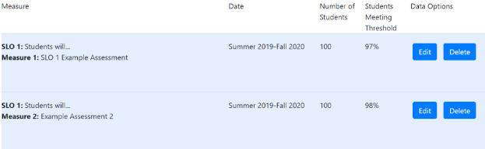

What if my data looks different than what can be added into the data table?
If your data looks different, upload the data using the “Supplements” portion of “Section III: Data.” Afterward, manually indicate whether each SLO was met, partially met, etc. in the “SLO Status” portion.
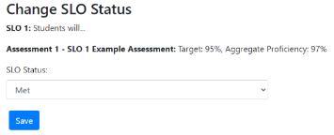

What does the blue “Clear Overrides” button do in the “Data Table” portion of “Section III: Data?”
If you manually aggregate your data using the “Edit Aggregate” button, the system stops automatically updating the aggregate even if more data is provided. To allow the system to automatically update again, click the blue “Clear Overrides” button.
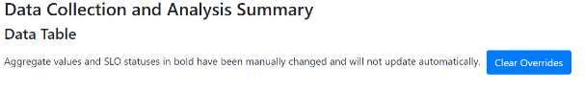

What if I want to cancel without saving when adding an SLO, assessment measure, and so on?
In sections that have a “Save” button or an “Add” button, you can hit the back arrow at the top of your screen to cancel without saving.
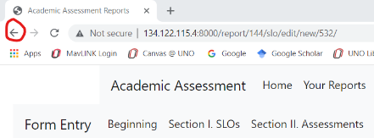

What if I do not use threshold metrics to analyze my assessment data?
For the non-accredited assessment report, the current form requires you to enter a proficiency threshold and target when adding a new assessment under Section II: Assessments. If you do not use threshold metrics to analyze your assessment data, please write “Threshold metrics are not used to analyze this SLO” in the proficiency threshold box. For the proficiency target number, please insert a “0” and then click the “Add Assessment” button. Next, click the “Upload Supplement” button for that measure and upload a brief description of your analytic strategy (e.g., Cohen’s d).
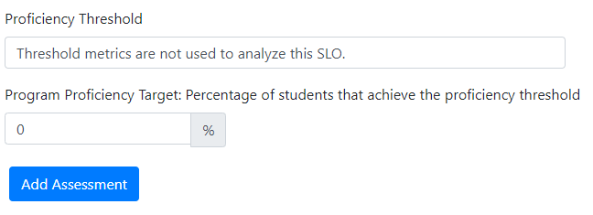
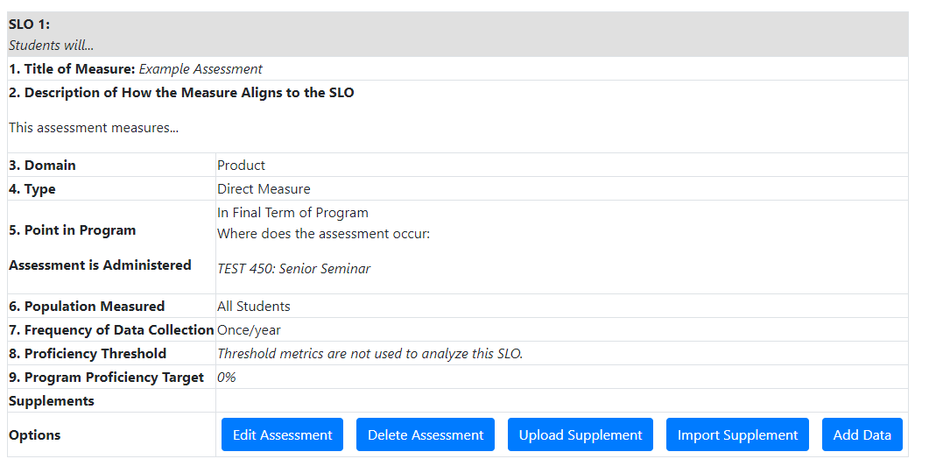

Additionally, the current form requires you to enter how many students met or exceeded the proficiency threshold when adding data under Section III: Data. Please insert a “0” for that part and then click the “Add Data” button. Next, click “Add Supplement” below the data table, and upload a brief summary or chart of your data analysis.
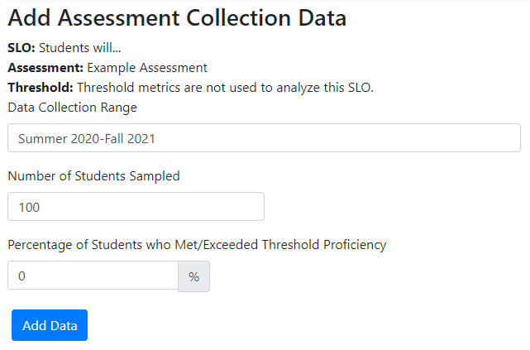
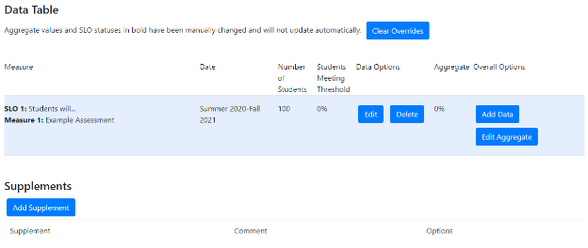

I have additional questions that are not answered in this guide.
Please reach out to programassessment@unomaha.edu with any additional questions.

