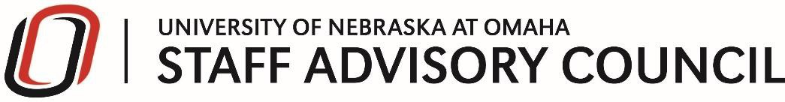

Staff Advisory Council Meeting Agenda Tuesday, Jan 14, 2020
PKI – Peter Kiewit Institute Room #158 - Fishbowl

Speaker
- UNO HR Cecil Hicks & Team

Call to Order
- Approval of Minutes
- President’s Report (Steven Summers)
- Treasurer’s Report (Sarah McGrath)

SAC Committee Reports
- Events Committee (Melissa Eckstein)
- Professional Development Committee (Laura Sherwin)
- Community Engagement Committee (Heike Langdon)
- Strategic Planning Committee (Thomas Walker)

Additional Business

UNO Wide Committees – Report

Elections – 6 office and 7 managers

New Business
- WiSTEM Survey
- Chair for Parking Advisory and Transit Committee
- On the Calendar

Good of the Order

Adjourn

Next SAC Meeting
Tuesday, February 11th, 9:00 –10:30 AM
Thompson Alumni Center – Centennial Hall
Regent Elizabeth O’Connor

