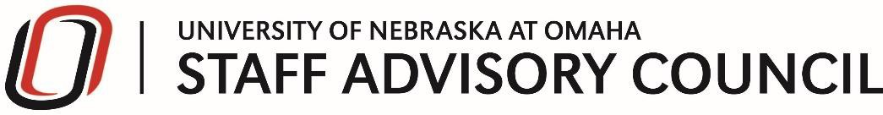

Staff Advisory Council Meeting Agenda

Tuesday, February 11th, 9:00 –10:30 AM

Thompson Alumni Center – Bootstrapper Hall

Regent Elizabeth O’Connor

Barb Harvey – Maverick Discount

Call to Order
- Approval of Minutes
- President’s Report (Steven Summers)
- Treasurer’s Report (Sarah McGrath)

SAC Committee Reports
- Events Committee (Melissa Eckstein)
- Professional Development Committee (Laura Sherwin)
- Community Engagement Committee (Heike Langdon)
- Strategic Planning Committee (Thomas Walker/Kirsten Case)

Additional Business

UNO Wide Committees – Report

Elections – 6 office and 7 managers

Compensation Imperative

I Love NU Day – March 10

SAC Banquet April 15th

New Business
- Spirit of Service Award Nomination - $1000
- Vote on new awards – Vevox
- Great Race – End of April
- CCSGE Banquet Feb 25th
- UNO/UNMC Faculty and Staff register for $15! April 25 at Baxter Arena for the Claussen-Leahy Maverick Run! DISCOUNT CODE STAFF 15

Good of the Order

Adjourn

Next SAC Meeting
Tuesday, March 10th, 9:00 –10:30 AM

